

**COURSE PROJECT REPORT**

**FPT University Admissions Consulting System ( FACS )**

**Subject: SWD392**

– Ho Chi Minh, July 2025 –

**Table of Contents**

Record of Changes 3

I. Overview 4

I.1 Project Information 4

I.2 Project Team 4

II. Requirement Specification 4

II.1 Problem description 4

II.2 Major Features 4

II.3 Context Diagram 4

II.4 Nonfunction Requirements 5

II.5 Functional requirements 5

II.5.1 Actors 5

II.5.2 Use Cases 5

II.5.2 .1 Diagram(s) 5

II.5.2.2 Use case descriptions 6

**II.5.3 Activity diagram** 8

III. Analysis models. 9

III.1 Interaction diagrams 9

III.2 State diagram 10

IV. Design specification 11

IV.1 Integrated Communication Diagrams 11

IV.2 System High-Level Design 11

IV.3 Component and Package Diagram 11

IV.4 Class diagram 12

IV.5 Database Design 12

V. Implementation 13

V.1 Map architecture to the structure of the project 13

V.2 Map Class Diagram and Interaction Diagram to Code 13

V. Applying Alternative Architecture Patterns 13

V.1 Applying the service-oriented architecture 13

V.2 Applying Service Discovery Pattern in the service-oriented architecture 13

# Record of Changes

| **Date** | **A* M, D** | **In charge** | **Change Description** |
| --- | --- | --- | --- |
| 27/05 | A | anhttse185016 | Describe ”Problem description”, “Major Features” |
| 02/06 | A | anhttse185016 | Write “Functional requirements - I.5.1”, “Use case descriptions - Table I.1, Table I.2” |
| 03/06 | A | anhttse185016 | Write “Use case descriptions - Table I.3, Table I.4, Table I.5, Table I.6, Table I.7, Table I.8” |
| 04/06 | A | anhttse185016 | Write  “Use case descriptions - Table I.9, Table I.10, Table I.11, Table I.12, Table I.13, Table I.14” |
| 05/06 | A | anhttse185016 | Write “Use case descriptions - Table I.14, Table I.15, Table I.16, Table I.17, Table I.18” |
| 06/06 | A | anhttse185016 | Write “Use case descriptions - Table I.19, Table I.20, Table I.21, Table I.22, Table I.23, Table I.24” |
| 06/06 | A | baotdqse183377 | Write “Use case descriptions - Table I.25, Table I.26, Table I.27, Table I.28, Table I.29, Table I.30” |
| 08/06 | D | anhttse185016 | Modify “Use case descriptions - Table I.25, Table I.26, Table I.27, Table I.28, Table I.29, Table I.30” |
| 08/06 | A | anhttse185016 | Add “Major Features” |
| 04/07 | M | anhttse185016 | Modify “Use case descriptions - UC_01, UC_02, UC_03, UC_04, UC_05, UC_06, UC_07, UC_08,UC_09,UC_10, UC_11, UC_12” |
| 04/07 | A | anhttse185016 | Add functional requirements - “Actors”, Business Rules (1 - 5), Diagram(s) ( 1 - 12 ) |
| 05/07 | M | anhttse185016 | Modify “Use case descriptions - UC_13, UC_14, UC_15, UC_16, UC_17, UC_18, UC_19, UC_20, UC_21,UC_22, UC_23, UC_24” |
| 05/07 | A | anhttse185016 | Add functional requirements - “Actors”, Business Rules  (6 - 11), Diagram(s) ( 13 - 24 ) |
| 08/07 | A | baotdqse183377 | Add UC_25. UC_26, SE.1, SE.2, SE.3, SE.4, SE.5, SE.6, SE.7, SE.8, SE.9, SE.10, SE.11, SE.12, SE.13, SE.14, SE.15, SE.16, SE.17, SE.18, SE.19, SE.20 |
| 10/07 | A | hyndse183790 | Add state diagram, Activity Diagram Admin DashBoard Overview, Activity Diagram Consultant Dashboard Overview, Activity Diagram Applicant Dashboard Overview |
| 11/07 | A | baotdqse183377 | Add System high-level design, Package Diagram, Entity Relationship Diagram (Conceptual, Logical, Physical) |
| 12/07 | A | baotdqse183377 | Add UserService, BookingService, ApplicationService, Notification Service class diagram |
| 12/07 | A | vynkse180305 | Add Activity Diagram Update admission stage |
| 13/07 | A | vynkse180305 | Add Activity Diagram Delete admission stage |
| 14/07 | A | haitdse183862 | Add Activity Diagram User Login, Activity Diagram Register Admission Consulting, Activity Diagram View Applicant Status, Activity Diagram Update Admission Status, Activity Diagram Delete Admission Briefcase, Activity Diagram View Admission Briefcase, Activity Diagram Admin Create User Account |
| 17/07 | A | haitdse183862 | Add Activity Diagram Chatting With AI Chatbot, Activity Diagram Search Briefcase, Activity Diagram Update User Account |
| 17/07 | M | haitdse183862 | Modify SE.22, SE.23, SE.24 |
| 17/07 | M | baotdqse183377 | Modify SE.3, SE.4, SE.5, SE.1, SE.2, SE.7, SE.8, SE.9, SE.10, SE.11, SE.12, SE.13, SE.14, SE.15, SE.16, SE.17, Context diagram |

*A - Added M - Modified D - Deleted

# I. Overview

## I.1 Project Information

* Project name: FPT University Admissions Consulting System
* Project code: FACS
* Group name: Group 3
* Software type: Website

## I.2 Project Team

| **Full Name** | **Role** | **Email** | **Mobile** |
| --- | --- | --- | --- |
| **Lê Hữu Hải Trí** | Leader | TriLHHSE183828@fpt.edu.vn | 0362740921 |
| Trương Điền Quốc Bảo | Member | baotdqse183377@fpt.edu.vn | 0869255375 |
| Trần Tuấn Anh | Member | anhttse185016@fpt.edu.vn | 0901498220 |
| Trần Đăng Hải | Member | haitdse183862@fpt.edu.vn | 0348393932 |
| Nguyễn Kỳ Vỹ | Member | vynntse183453@fpt.edu.vn | 0853880450 |
| Nguyễn Đức Hy | Member | hyndse183790@fpt.edu.vn | 0365502741 |

# II. Requirement Specification

## II.1 Problem description

To modernize and improve the student admission process, FPT University plans to develop a web-based Admission Consulting System integrating with AI chatbot that allows prospective students to register online for enrollment. The goal is to reduce manual work, improve data accuracy, and provide a centralized system for handling applicants information. The system requirements are described as follows:

1. The applicant registers for admissions consulting. Applicant ought to fully fill in consulting registration form to get directly response from consultant department. Then, the consultant take obligation for proactively contacting to applicant with purpose of transferring as well as understanding wonders, personal demands, matters about majors, college and advanced academic environment, which support applicant to learn more basic information on career path afterward.
2. The applicant could register for college admission, additionally. After a while getting back the precious acknowledges about university, the students get easily access to complete admission forms. These ones comprise two specific categories, admission- entrance exam which have dependence on applicant’s purpose. The consultant then takes responsibility to manage these applicant briefcases. Consultant could view obviously registering list, manage applicant, search applicant, update admissions stages, delete applicant, view briefcase detailed, require supplementary profile as well.
3. After having registered for admission, applicant could view application status. These interactions belong to consulting department. The consultant absolutely has duties in registering management. The default stage in briefcase is waiting, which must be updated manually by consultants when they have confirmed the profile category being approving process and this one might meet university’s entrancing requirements. Applicant must complement depending on these ones.
4. The applicant research for admission result based on ID provided specifically in email after having registered. Besides, the applicant plays a virtual role in updating stages process that must comply with school’s academic  regulations.
5. Applicant pleasantly search admissions information of university basing on wonders, demands of their own that university has published on website detailed about headlines, school fees, semesters, scholarship policy and so on.
6. The applicant could have conversations with Chatbot AI integrated deeply into consulting system. With purpose of mitigating time leaving out as providing data accuracy, chatbot has been trained in order to enhance user experience but still being concordant in educational field.
7. Administrator plays a significant role in manage users account. These managements include primary actions, users account-admissions content. In terms of users account, administrator have total rights in view user account, create account, update profile account as well as delete.
8. Beside, administrator have access to manage admissions content, which comprises the specific activities from view admissions content, create admissions content to update admissions content as well as delete admissions content.
9. Moreover, the administrator could view visual dashboard to recognize, evaluate the influence on academic aspect from college. From then, administrator could have proper configuration to get more attractively content, which could have impacts on students’ awareness.
10. Administrator, Consultant as well must login to consulting system with inner account provided in advance. In case of having forgotten password, the consultant must urgently contact to administrator so as to be got support immediately.

## II.2 Major Features

| **ID** | **Name** | **Description** | **Actors** | | |
| --- | --- | --- | --- | --- | --- |
|  | | | Applicant | Consultant | Administrator |
| F01 | Reseach Information Management | Search admissions information, Look up admission result. | **X** |  |  |
| F02 | Registration Management | Register for Admissions Consulting, Register for Admission (entrance exam, admission), Fill in registration form. | **X** |  |  |
| F03 | Academic Transcript Submission | Fill in Admission form, Check schoolrank. | **X** |  |  |
| F04 | Application Status | Research for application result, Follow application stages, Supplement profile. | **X** |  |  |
| F05 | Viewing homepage detailed | View admissions information, View newly articles, View articles detailed, Search news. | **X** |  |  |
| F06 | Chatting with AI chatbot | Ask about admissions information (school fee, campus,regulations & policies,...), Create Admissions Consulting/ Admission form (get admissions support from University’s consulting department). | **X** |  |  |
| F07 | Consultant Authentication | Login with inner account provided, Manage profile ( View personal profile, Update profile). |  | **X** |  |
| F08 | Applicant briefcase Management | View admissions registering list, Manage Admission Briefcase (Search applicant, View briefcase detailed, Update applicant briefcase, Update admissions stages, Delete applicant). |  | **X** |  |
| F09 | Admissions Consulting Briefcase Processing | View admissions list, View applicant profile detailed, Confirm briefcase, Resolve briefcase stages, Approve applicant briefcase successfully/rejected. |  | **X** |  |
| F10 | Admission Briefcase Processing | View admission list, View applicant profile detailed, Confirm briefcase, Resolve briefcase stages, Approve applicant briefcase approved/rejected. |  | **X** |  |
| F11 | Administrator Authentication | Login with inner account provided, Manage profile (View personal profile, Update profile). |  |  | **X** |
| F12 | User Management | View, Create, Update, Delete user account. |  |  | **X** |
| F13 | Admissions content Management | View, Create, Delete, Update admissions content (school fee, entrance exam policy, academic regulations, newly articles ). |  |  | **X** |
| F14 | Viewing visual dashboard | View statistical dashboard detailed ( amount of applicants registered, provinces, which majors mostly paying attention ). |  |  | **X** |

## II.3 Context Diagram

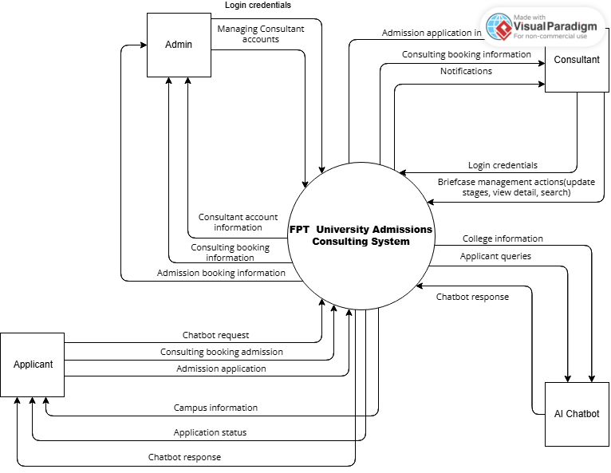

## II.4 Nonfunctional requirements

| **#** | **Feature** | **System Function** | **Description** |
| --- | --- | --- | --- |
| 1 | NF-01 | **Performance** | The system must be able to respond to users within ≤ 10 seconds for 95% of queries. |
| 2 | NF-02 | **Availability** | The system must ensure a minimum uptime of 99% per month. |
| 3 | NF-03 | **Scalability** | The system must support a minimum of 500 concurrent users without sacrificing performance. |
| 4 | NF-04 | **Maintainability** | The system source code must be designed to be easy to maintain so that chatbot content and functionality can be updated within 2 business days. |
| 5 | NF-05 | **Security** | User data must be encrypted when stored and transmitted, especially personal information. |

## II.5 Functional requirements

### II.5.1 Actors

| **#** | **Actor** | **Description** |
| --- | --- | --- |
| 1 | **Applicant** | **The applicant** is the end user of the admissions system – a student or candidate who needs to find admissions information and apply to a university (admission). They can perform various functions within the system with the goal of researching, applying, and tracking the admission briefcase process as well.   1. **Research admissions information**  * Search for general admission information on the system. * Research information from official sources provided on the system, including policies, admission conditions, majors, quotas, etc.  1. **Search for admission result**  * Check individual admission results (e.g. SchoolRank results). * You can receive admission result when admission results are available.  1. **View homepage detailed**  * Access the main interface of the admissions page to: View banners, news, admissions events, registration ( admissions consulting or admission ).  1. **View application status**  * Track the status of your admission application (e.g. waiting , processing, approved, rejected).  1. **Manage registration**  * Track, edit, or cancel previously made registrations. * View detailed home page * View updated information from the school such as admissions news, media banners, events, etc. * From here, you can access functions such as registering for admissions counseling. * Register for admissions counseling  1. **Check SchoolRank Result**  * Check the learning ranking from the SchoolRank system (if available)**.**  1. **Chat with AI Chatbot**  * Send questions and receive automatic responses from AI Chatbot to answer admissions information. * You can start a chat with requests such as: * Ask for admissions information. * Request to register for admissions. * Request to register for admissions counseling. |
| 2 | **Consultant** | **Consultants** are people in the admissions consulting department who have access to the system through an internal account (authenticated account). They act as intermediaries between the school and candidates, responsible for consulting, monitoring, and processing candidates' registration briefcases— including both admission and consulting briefcases.   1. **Log in to the system**  * Login with username/password: Log in to the system with an internal account. * Forget password: Send a recovery request to Administrator through inner email. * Logout: Log out of the system.  1. **Consulting briefcase management**  * Search briefcase: Search for consulting profiles by keyword, code or candidate name. * View admissions registering list: View the list of candidates who have registered for consulting. * Manage Registered Consulting briefcase: Manage the list of registered consulting profiles: * Update consulting stages: Update consulting progress. * Delete briefcase: Update consulting briefcase stages that are no longer valid.  1. **Admission Briefcase management**  * Search applicant: Search for applicants and their applications. * Manage Admission briefcase: Manage the list of applicants' applications. * Update admissions stages: Update admission stages. * Update applicant briefcase: Update detailed application content. * Delete applicant briefcase: Update application briefcase in case of being invalid. * View briefcase detailed: View details of each application. |
| 3 | **Administrator** | **Admin** is the system administrator, has internal access and full control over the main components of the admission system.   1. **Login to the system**  * Login with username, password: Log in with the system administrator account. * Logout: Log out of the system.  1. **Manage personal profile**  * View personal user account: View your own account information. * Update user’s profile account: Update personal information.  1. **Manage user accounts**  * View users account: Perform all system account list managemen. * Create user account: Create a new user account (for example, create an account for a consultant or employee). * Update user’s profile account: Update user account information. * Delete user account: Delete a user account when necessary (for example, when an employee leaves, the account is incorrect...).  1. **Manage admissions content**  * Manage admissions content: Manage all displayed content related to admissions. * Create admissions content: Create new articles, announcements, banners, admissions policies. * Update admissions content: Edit posted admissions content. * Delete admissions content: Delete content that is no longer relevant. * View admissions content: View all admissions content currently on the system. |

### II.5.2 Use Cases

### II.5.2 .1 Diagram(s)

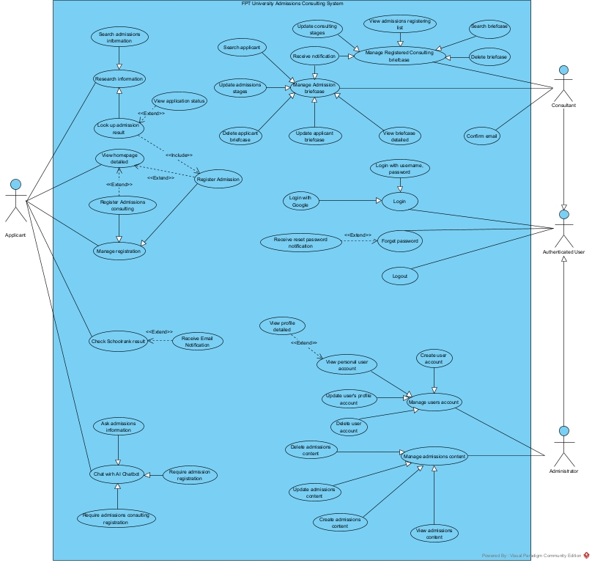

| **ID** | **Use Case** | **Actors** | **Use Case Description** |
| --- | --- | --- | --- |
| 01 | Register Admissions consulting | Applicant | This use case allows the Applicant to register admissions consulting depending on personal demands as well as wonders in system. |
| 02 | Update admissions stages | Consultant | This use case allows the Consultant to update admissions briefcase stages in the system. |
| 03 | Update Applicant briefcase | Consultant | This use case describes the process by which a Consultant updates an applicant's briefcase within the system. |
| 04 | Delete applicant briefcase | Consultant | This use case describes the process by which a Consultant delete applicant from the system by update stage. |
| 05 | Search applicant | Consultant | This usecase allows the Consultant to search Applicant so as to find out the detailed admission briefcase within the system. |
| 06 | View briefcase detailed | Consultant | This usecase allows the Consultant to view applicant briefcase detailed within the system. |
| 07 | View admissions registering list | Consultant | This use case allows the Consultant to view the list of applicants who have registered for admissions consulting. |
| 08 | Search briefcase | Consultant | This use case allows the Consultant to search for applicant briefcases that registers for consulting within the system. |
| 09 | Update consulting stages | Consultant | This use case allows the Consultant to update consulting stages in the system. |
| 10 | Register Admission | Applicant | This use case allows the Applicant to register admission based on personal aspiration with intention of applying to university. |
| 11 | Search admissions information | Applicant | This use case allows the Applicant to search admissions information with the purpose of acknowledging more about university. |
| 12 | Look up admission result | Applicant | This use case allows the Applicant to look up result for admission which they submitted briefcase to university in advance. |
| 13 | View application status | Consultant | This use case allows the Applicant view admission briefcase status after looking up info. |
| 14 | Check Schoolrank result | Applicant | This use case allows the Applicant check Schoolrank result on University’s system dedicated to the ones who have aspiration for admissions into college. |
| 15 | Create user account | Administrator | This use case allows the Admin to create a new user account in the system for internal role such as Consultants. |
| 16 | View user account | Administrator | This use case allows the Admin to view a list of user accounts existing within the system. |
| 17 | Update user's profile account | Administrator | This use case allows the Admin to update user profile information existing internally within the system. |
| 18 | Delete user account | Administrator | This use case allows the Admin to permanently delete a user account from the system when account is no longer or invalid. |
| 19 | View admissions content | Administrator | This use case allows the Admin to view a list of existing admissions content items (articles, policies, events, banners) that have been posted on the university’s admissions portal. |
| 20 | Create admissions content | Administrator | This use case allows the Admin to create new admissions content such as news, policies, events, or banners on the university’s admissions system. |
| 21 | Update admissions content | Administrator | This use case allows the Admin to edit and update existing admissions content such as news, policies, events, or banners that are stored in the system. |
| 22 | Delete admissions content | Administrator | This use case allows the Admin to permanently delete admissions content (news, policies, events, or banners) from the system. |
| 23 | Login | Administrator  Consultant | This use case allows the Admin as well as the Consultant login with internal account provided so as to conduct the following actions within the system. |
| 24 | Logout | Administrator  Consultant | This use case allows the Admin as well as the Consultant logout within the system. |
| 25 | Receive notification | Consultant | This use case allows the Consultant to receive notification when an admission briefcase is assigned him |
| 26 | Confirm email | Consultant | This use case allows a Consultant to confirm their email address after the Admin creates their account. The system sends a confirmation link via email, and upon clicking it, the Consultant’s account is activated and redirect back to the system. This ensures the email is valid before allowing login. |

1**UC_01_RegisterAdmissionsConsulting**

| Use Case ID | **UC-01** | | |
| --- | --- | --- | --- |
| Name: | **Register Admissions consulting** | | |
| Created By: | Anhtt | Date Created: | 31/05/2025 |
| Primary Actor: | Applicant | Secondary Actors: | None |
| Description: | This use case allows the Applicant to register admissions consulting depending on personal demands as well as wonders in system. | | |
| Trigger: | The Applicant selects the Register Admissions Consulting item appearing throughout on the homepage screen. | | |
| Preconditions: | PRE-1. The Applicant chooses Register item.  PRE-2. The Applicant select Admissions Consulting section for registeration. | | |
| Postconditions: | **POST-1.** **Successful Registration**: The newly admissions registering form is added to the system. The system will display message “Registered Consulting Successfully”.  **POST-2. Unsuccessful Registration**: The system will notice the specifically error message is “Registered Failed, Please try again.” on the screen. The Applicant is required to re-register admisions consulting. | | |
| Normal Flow: | 1. The Applicant view homepage detailed.  2. The system will display “Register” button throughout on the homepage menu screen. (See A2.1)  3. System will show optional registeration for choosing.  4. The Applicant select “Admissions Consulting” item.  5. The system will have navigation to Admissions Consulting screen.  6. The Applicant must fill in Register form entirely. (See E6.1)  7. The Applicant choose “Register Consulting” button for submission.  8. The system will process input validation, make sure the mandatory section would be entered completely.  9. The system will exhibit confirmative message that the application has been successfully submitted.  10. The system will navigate back to homepage screen. | | |
|  |  | | |
| Alternative Flows: | **A2.1 The Applicant chooses to register directly via the embedded button on the homepage banner (Step 2)**  1. The Applicant sees a registration button embedded directly on the homepage banner screen.  2. The Applicant chooses “Register Now” item.  3. The system proceeds with Step 5 of the Normal Flow. | | |
| Exceptions: | **E6.1 Missing Required Fields (Step 6)**  1. The Applicant click on Register button for submission without enrolling form completely.  2. The system detects that one or more mandatory fields are empty.  3. The system displays an error message: “Please fill out all of fields” beneath each of row.  4. Once the missing fields are completed, the process continues at Step 8 of the Normal Flow. | | |
| Priority: | High | | |
| Frequency of Use: | High | | |
| Business Rules: | BR-01 | | |
| Other Information: | None | | |
| Assumptions: | - Applicant has a stable internet connection.  - The admissions registration is currently existed.  - The applicant has already reviewed the admissions requirements. | | |

**UC_02_UpdateAdmissionsStages**

| Use Case ID: | **UC-02** | | |
| --- | --- | --- | --- |
| Name: | **Update admissions stages** | | |
| Created By: | Anhtt | Date Created: | 02/06/2025 |
| Primary Actor: | Consultant | Secondary Actors: | None |
| Description: | This use case allows the Consultant to update admissions briefcase stages in the system. | | |
| Trigger: | The Consultant chooses Update Stages button based on the applicant’s briefcase specifically displayed on the screen. | | |
| Preconditions: | PRE-1. The Consultant is logged into the system using a valid internal account.  PRE-2. The Consultant has selected the "Manage Applicant Briefcase" menu item.  PRE-3. The Consultant chooses Manage Admission briefcase section.  PRE-4. The Consultant clicks on Update Stages button corresponding to the briefcase that needs updating stage. | | |
| Postconditions: | **POST-1.** **Successful Update**: The applicant's briefcase stage is updated successfully. The new stage is saved. A confirmation message is “Update Applicant Briefcase Stage Successfully” displayed in the system.  **POST-2. Unsuccessful Update**: The system displays an error message is “Update Failed”. The Consultant must retry update process. | | |
| Normal Flow: | 1. The Consultant logged into the system with inner account. 2. The system will navigate to the screen dedicated to the Consultant. 3. The Consultant chooses “Manage Applicant Briefcase” on menu bar. 4. The Consultant selects “Manage Admission briefcase” item. 5. The system will display applicant briefcase list detailed. 6. The Consultant clicks on “Update Stages” button with specific briefcase for update. 7. The system transfers to stages screen for updating preparation. 8. The Consultant selects stage using selection button. 9. The Consultant clicks on “Update Briefcase” button. (See A8.1) (See E8.1) 10. The system will exhibit a confirmative message to notice that the applicant briefcase stage has been successfully updated. | | |
|  |  | | |
| Alternative Flows: | **A8.1 Selected stage is familiar to the Current stage (Step 8)**   1. The system validates the selected stage upon clicking “Save” button. 2. The system detects that the selected stage is identical to the current stage of the applicant’s briefcase. 3. The system displays a warning message: "The selected stage is the same as the current stage. No changes have been made." 4. The system remains on the current screen and allows the Consultant to choose another stage. 5. The system proceeds with Step 8 of the Normal Flow. | | |
| Exceptions: | **E8.1 Error occurring in saving stage update (Step 8)**   1. The system attempts to send the update request to the server. 2. Due to a system error (server error or database issue), the update request fails. 3. The system displays an error message: “Failed to update the stage. Please try again.” 4. The system remains on the current screen, allowing the Consultant to retry. 5. The Consultant may attempt to save again (returned to Step 8 of the Normal Flow). | | |
| Priority: | High | | |
| Frequency of use: | High | | |
| Business Rules: | BR-02 | | |
| Other Information: | None | | |
| Assumptions: | - The consultant has access to the “Applicant Briefcase Management” function.  -The system operates stably, there is no fixed network or server error at the time of operation.  -The application data profile has been fully updated, without missing necessary information. | | |

**UC_03_UpdateApplicantBriefcase**

| Use Case ID: | **UC-03** | | |
| --- | --- | --- | --- |
| Name: | **Update applicant briefcase** | | |
| Created By: | Anhtt | Date Created: | 03/06/2025 |
| Primary Actor: | Consultant | Secondary Actors: | None |
| Description: | This use case describes the process by which a Consultant updates an applicant's briefcase within the system. | | |
| Trigger: | The Consultant clicks on Update Briefcase button corresponding to applicant specifically displayed on the screen. | | |
| Preconditions: | PRE-1. The Consultant is logged into the system using a valid internal account.  PRE-2. The Consultant has selected the "Manage Applicant Briefcase" menu item.  PRE-3. The Consultant chooses Manage Admission briefcase section.  PRE-4. The Consultant clicks on Update Briefcase button corresponding to the briefcase that needs updating. | | |
| Postconditions: | **POST-1.** **Successful Update**: The applicant's briefcase is updated successfully. The new briefcase is saved. A verified message is “Update Applicant Briefcase Successfully” displayed in the system.  **POST-2. Unsuccessful Update**: The system displays an error message is “Update Failed, Please try again”. The Consultant must retry update process.  **POST-3. Temporarily Update**: The system displays confirmative message ‘The applicant briefcase has been temporarily updated. Please follow up to complete the missing information” in the system. | | |
| Normal Flow: | 1. The Consultant logged into the system with inner account. 2. The system will navigate to the screen dedicated to the Consultant. 3. The Consultant chooses “Manage Applicant Briefcase” on menu bar. 4. The Consultant selects “Manage Admisison Briefcase” item. 5. The system will display applicant briefcase list detailed. 6. The Consultant clicks on “Update Briefcase” button with specific briefcase for update. 7. The system navigates to detailed applicant briefcase screen for update. 8. The Consultant supplements applicant briefcase into compulsory fields. 9. The Consultant clicks on “Save” button. (See A9.1) ( See E9.1) 10. The system will exhibit a confirmative message to notice that the applicant briefcase has been successfully updated. | | |
|  |  | | |
| Alternative Flows: | **A9.1 Partly update with Missing info (Step 9)**   1. The Consultant updates the applicant briefcase but leaves some fields (usual marked as mandatory ones) empty. 2. The system detects the missing required fields but allows the briefcase to be saved. 3. The system displays a confirmative message: “The applicant briefcase has been temporarily updated. Please follow up to complete the missing information”. 4. The system proceeds with the Step 10 of Normal Flow. | | |
| Exceptions: | **E9.1 System error during data saving process (Step 9)**   1. The Consultant clicks on the “Save” button after supplementing the briefcase. 2. The system attempts to process and persist the updated data. 3. The system error occurs ( connection lost, database error..) 4. The system fails to save the briefcase and does not update the record. 5. The system displays an error message to the Consultant screen: “Update Failed due to a system error. Please try again”. 6. The Consultant remains on the update screen and may attempt to retry updating data. | | |
| Priority: | High | | |
| Frequency of Use: | High | | |
| Business Rules: | BR-02 | | |
| Other Information: | None | | |
| Assumptions: | - The consultant has access to the “Applicant Briefcase Management” function.  -The system operates stably, there is no fixed network or server error at the time of operation.  -The application data profile has been fully updated, without missing necessary information. | | |

**UC_04_DeleteApplicantBriefcase**

| Use Case ID: | **UC-04** | | |
| --- | --- | --- | --- |
| Name: | **Delete applicant briefcase** | | |
| Created By: | Anhtt | Date Created: | 03/06/2025 |
| Primary Actor: | Consultant | Secondary Actors: | None |
| Description: | This use case describes the process by which a Consultant delete applicant from the system. | | |
| Trigger: | The Consultant clicks on Update button corresponding to applicant specifically displayed on the screen. | | |
| Preconditions: | PRE-1. The Consultant is logged into the system using a valid internal account.  PRE-2. The Consultant has selected the "Manage Applicant Briefcase" menu item.  PRE-3. The Consultant chooses “Manage Admission Briefcase” section.  PRE-4. The Consultant clicks on “Update” button corresponding to the briefcase that needs deleting.. | | |
| Postconditions: | **POST-1.** **Successful Delete**: The applicant's briefcase is deleted successfully. A verified message is “Update Applicant Briefcase Successfully” displayed in the system.  **POST-2. Unsuccessful Delete**: The system displays an error message is “Update Failed, Please try again”. The Consultant must retry delete process.  **POST-3. Deletion Cancelled** **by Consultant**: If the Consultant cancels the deletion confirmation, the briefcase is not deleted. The system remains unchanged and no confirmation or error message is shown. | | |
| Normal Flow: | 1. The Consultant logged into the system with inner account. 2. The system will navigate to the screen dedicated to the Consultant. 3. The Consultant chooses “Manage Applicant Briefcase” on menu bar. 4. The Consultant selects “Manage Admission briefcase” item. 5. The system displays applicant briefcase list detailed. 6. The Consultant clicks on “Update” button with specific briefcase for delete. (See A6.1) ( See E6.1) 7. The Consultant choose “Rejected” selection item. 8. The system update applicant briefcase. 9. The system will exhibit a confirmative message to notice that the applicant briefcase has been successfully updated. | | |
|  |  | | |
| Alternative Flows: | **A6.1 – User Cancels Deletion Confirmation (Step 6)**.   1. The Consutant clicks on “Back” button in the screen. 2. The system cancels deleting process. 3. The system returns to applicant briefcase list detailed. | | |
| Exceptions: | **E10.1 System Error During Deletion Process (Step 10)**   1. The system attempts to remove the briefcase record from the database. 2. System error occurs (might database error, timeout ..) 3. The system displays error message on the screen “Deletion failed due to a system error. Please try again”. 4. The Consultant still remains on the briefcase detailed so as to retry deleting. | | |
| Priority: | High | | |
| Frequcncy of Use: | Must Have | | |
| Business Rules: | BR-02  BR-03 | | |
| Other Information: | None | | |
| Assumptions: | * “Deleting” a record means changing the stage of the record to “Rejected”, not physically deleting the data from the database. * The “Rejected” stage is a valid value defined in the system stages list. * After the file is moved to “Rejected”, the system still retains the file data for future reference or reporting. | | |

**UC_05_SearchApplicant**

| Use Case ID: | **UC-05** | | |
| --- | --- | --- | --- |
| Name: | **Search applicant** | | |
| Created By: | Anhtt | Date Created: | 03/06/2025 |
| Primary Actor: | Consultant | Secondary Actors: | None |
| Description: | This usecase allows the Consultant to search Applicant so as to find out the detailed admission briefcase within the system. | | |
| Trigger: | The Consultant clicks on Search button corresponding to looking up on the screen. | | |
| Preconditions: | PRE-1. The Consultant is logged into the system using a valid internal account.  PRE-2. The Consultant has selected the "Manage Applicant Briefcase" menu item.  PRE-3. The Consultant chooses “Manage Admission Briefcase” section.  PRE-4. The Consultant enters applicant briefcase information needs looking up on searching bar. | | |
| Postconditions: | **POST-1.** **Successful Search**: The applicant's briefcase is found successfully.  **POST-2. Unsuccessful Search**: The system displays an error message is “Briefcase Not Found” on the screen.. The Consultant must retry searching process. | | |
| Normal Flow: | 1. The Consultant logged into the system with inner account. 2. The system will navigate to the screen dedicated to the Consultant. 3. The Consultant chooses “Manage Applicant Briefcase” on menu bar. 4. The Consultant selects “Manage Admission briefcase” item. 5. The system displays applicant briefcase list detailed. 6. The Consultant enters applicant information into searching bar. (See A6.1) (See A6.2) (See E6.1) (See E6.2) 7. The Consultant clicks on “Search” button to find out applicant briefcase detailed. 8. The system resolves for a while to research inputted information corresponding to database and displays applicant list.. 9. The system displays obviously applicant briefcase on the screen that the Consultant wanna find. 10. The Consultant continues at briefcase resolving process. | | |
|  |  | | |
| Alternative Flows: | **A6.1 – Skip Search and View All (Step 6)**   1. The Consultant does not input any search information on searching bar and clicks on “Search”. 2. The System returns all the applicant briefcase availably existing in the database. 3. The Consutant scrolls down to locate the appropriate applicant. 4. The system proceeds with the Step 10 of Normal Flow.   **A6.2 - Partial Match Results (Step 6)**   1. The Consultant enters partial or ambiguous information on searching bar ( only FirstName, only LastName or partial ID briefcase ..). 2. The system processes and returns multiple briefcases that suits with partial match in database 3. The system displays list of potential applicant briefcase on the screen. 4. Control is returned to Step 10 of Normal Flow. | | |
| Exceptions: | **E6.1 Invalid Characters (Step 6)**   1. The Consultant enters invalid or unsupported input in the search bar. (as $, *, … ). and clicks on “Search” button. 2. The system resolves for a while to research inputted information corresponding to database. 3. The system displays a validation message: “Invalid input detected. Please enter valid characters only.”. 4. The system stills remain on the screen and allows the Consultant re-enter. 5. The system proceeds with the Step 6 of Normal Flow.   **E6.2 System Error During Search Execution (Step 6)**   1. The system fails to process the search due to an internal error. 2. The system displays an error message on the screen: “System error occurred while searching. Please try again later.” 3. The Consultant remains on the search screen and can retry the search. | | |
| Priority: | High | | |
| Frequency of Use: | High | | |
| Business Rules: | BR-02  BR-03  BR-04 | | |
| Other Information: | None | | |
| Assumptions: | * Consulting stages are clearly defined and fixed by the system, and cannot be added arbitrarily at the time of update. * The new stage selected must be different from the current stage, unless the system allows confirmation of the duplicate operation * After the update is successful, the system must display a confirmation message and update the new status to the list of records. | | |

**UC_06_ViewBriefcaseDetailed**

| Use Case ID: | **UC-06** | | |
| --- | --- | --- | --- |
| Name: | **View briefcase detailed** | | |
| Created By: | Anhtt | Date Created: | 03/06/2025 |
| Primary Actor: | Consultant | Secondary Actors: | None |
| Description: | This usecase allows the Consultant to view applicant briefcase detailed within the system. | | |
| Trigger: | The Consultant clicks on View Detailed item so as to observe applicant briefcase in the system. | | |
| Preconditions: | PRE-1. The Consultant is logged into the system using a valid internal account.  PRE-2. The Consultant has selected the "Manage Applicant Briefcase" menu item.  PRE-3. The Consultant chooses “Manage Admission Briefcase” section. | | |
| Postconditions: | **POST-1. Successful View:** The system successfully displays the detailed information of the selected applicant briefcase.  **POST-2. Cancelled View:** The Consultant cancels the viewing request and remains on the briefcase list screen.  **POST-3. Failed View Due to Error**: If a system error occurs, the detailed screen is not displayed. An error message “error occurred while loading the applicant briefcase details. Please try again” is shown. | | |
| Normal Flow: | 1. The Consultant logged into the system with inner account. 2. The system will navigate to the screen dedicated to the Consultant. 3. The Consultant chooses “Manage Applicant Briefcase” on menu bar. 4. The Consultant selects “Manage Admission briefcase” item. 5. The system displays applicant briefcase list detailed. 6. The Consultant clicks on “View Detailed” item to observe specific applicant briefcase. (See A6.1) 7. The system transfers to detailed briefcase screen. (See E7.1) 8. The Consultant easily sees briefcase information corresponding to the applicant. 9. The Consultant clicks on “Back” button in order to return applicant briefcase list for the other charges. | | |
|  |  | | |
| Alternative Flows: | **A6.1 – User Cancels View Request (Step 6)**   1. The Consultant is on applicant briefcase list screen. 2. Instead of clicking on “View Detailed” item for observing briefcase details, the Consultant selects another action ( “Update Admissions Stages”, “Delete Applicant briefcase”,...). 3. The system does not proceed navigation to view detailed screen. 4. The Consultant remains on the list view and may continue with other actions. | | |
| Exceptions: | **E7.1 System Error While Loading Detailed View (Step 7)**   1. The system attempts to load the detailed data. 2. Due to a system error (server timeout, database disconnection..), the detailed applicant briefcase is not displayed. 3. The system notices the error message “An error occurred while loading the applicant briefcase details. Please try again”. 4. The Consultant remains on the briefcase list screen and may retry the action. | | |
| Priority: | Medium | | |
| Frenquency of Use: | Could Have | | |
| Business Rules: | BR-02 | | |
| Other Information: | None | | |
| Assumptions: | * The consultant has logged into the system with a valid internal account. * The consultant has access to view the candidate's profile details (e.g., under management, or the system allows global viewing). * The system has stored complete candidate profile data, including basic fields such as full name, profile code, date of birth, enrollment status, notes, etc. * The "Profile Details" interface is designed to display complete information but does not allow direct editing (read-only), unless the system grants specific editing rights. | | |

**UC-07***_***ViewAdmissionsRegisteringList**

| Use Case ID: | **UC-07** | | |
| --- | --- | --- | --- |
| Name: | **View admissions registering list** | | |
| Created By: | Anhtt | Date Created: | 03/06/2025 |
| Primary Actor: | Consultant | Secondary Actors: | None |
| Description: | This use case allows the Consultant to view the list of applicants who have registered for admissions consulting.. | | |
| Trigger: | The Consultant clicks the “Manage Registered Consulting Briefcase” item to access the list of registered applicants. | | |
| Preconditions: | PRE-1. The Consultant is logged into the system using a valid internal account.  PRE-2. The Consultant has selected the "Manage Applicant Briefcase" menu item.  PRE-3. The Consultant chooses “Manage Registered Consulting briefcase” section. | | |
| Postconditions: | **POST-1. Successful View:** The system successfully displays the admissions registering list screen. | | |
| Normal Flow: | 1. The Consultant logged into the system with inner account. 2. The system will navigate to the screen dedicated to the Consultant. 3. The Consultant chooses “Manage Applicant Briefcase” on menu bar. 4. The Consultant selects “Manage Registered Consulting briefcase” item. 5. The system retrieves and displays the list of applicants who registered for admissions consultation. (See A5.1) (See E5.1) 6. The Consultant reviews the list and proceeds with further action ( update status ). | | |
|  |  | | |
| Alternative Flows: | **A5.1 – No Applicants Found (Step 5)**   1. The system attempts to retrieve the list of registered applicant from database but no records existed. 2. The system displays a message: “No registered applicants found.” 3. The Consultant remains on the admissions registering list screen. 4. The Consultant may either refresh the page or return to the previous screen to conduct other actions. | | |
| Exceptions: | **E5.1 – System Error During Data Retrieval (Step 5)**   1. A database error occurs while loading the admissions registering list. 2. The system shows an error: “Unable to load registered applicant list. Please try again.” 3. The Consultant may retry or return to the main screen. | | |
| Priority: | High | | |
| Frequency of Use: | Must Have | | |
| Business Rules: | BR-02 | | |
| Other Information: | None | | |
| Assumptions: | * The consultant has logged into the system with a valid internal account. * The consultant has access to view the candidate's profile details (e.g., under management, or the system allows global viewing). * The system has stored complete candidate profile data, including basic fields such as full name, profile code, date of birth, enrollment status, notes, etc. * The "Profile Details" interface is designed to display complete information but does not allow direct editing (read-only), unless the system grants specific editing rights. | | |

**UC_08_SearchBriefcase**

| Use Case ID: | **UC-08** | | |
| --- | --- | --- | --- |
| Name: | **Search briefcase** | | |
| Created By: | Anhtt | Date Created: | 04/06/2025 |
| Primary Actor: | Consultant | Secondary Actors: | None |
| Description: | This use case allows the Consultant to search for applicant briefcases that registers for consulting within the system. | | |
| Trigger: | The Consultant inputs data into the search bar and clicks on “Search” button for research. | | |
| Preconditions: | PRE-1. The Consultant is logged into the system using a valid internal account.  PRE-2. The Consultant has selected the "Manage Applicant Briefcase" menu item.  PRE-3. The Consultant chooses “Manage Registered Consulting briefcase” section.  PRE-4. The Consultant enters applicant briefcase information needs looking up on search bar. | | |
| Postconditions: | **POST-1. Successful View:** The system successfully displays the admissions registering list screen.  **POST-2. Failed View Due to Error**: If a system error occurs, the detailed screen is not displayed. An error message “No Briefcase Found.” is shown. | | |
| Normal Flow: | 1. The Consultant logged into the system with inner account. 2. The system will navigate to the screen dedicated to the Consultant. 3. The Consultant chooses “Manage Applicant Briefcase” on menu bar. 4. The Consultant selects “Manage Registered Consulting briefcase” item. 5. The system retrieves and displays the list of applicants who registered for admissions consulting. 6. The Consultant inputs data needs researching into the search bar. (See A6.1) (See A6.2) (See E6.1) (See E6.2) 7. The Consultant clicks on “Search” button for looking up the briefcase. 8. The system displays briefcase information of applicant. 9. The Consultant reviews the list and proceeds with further action ( update status ). | | |
|  |  | | |
| Alternative Flows: | **A6.1 – Skip Search and View All (Step 6)**   1. The Consultant does not input any search information on searching bar and clicks on “Search”. 2. The System returns all the applicant briefcase availably existing in the database. 3. The Consutant scrolls down to locate the appropriate applicant. 4. The system proceeds with the Step 9 of Normal Flow.   **A6.2 - Partial Match Results (Step 6)**   1. The Consultant enters partial or ambiguous information on searching bar ( only FirstName, only LastName or partial ID briefcase ..). 2. The system processes and returns multiple briefcases that suits with partial match in database 3. The system displays list of potential applicant briefcase on the screen. 4. Control is returned to Step 9 of Normal Flow. | | |
| Exceptions: | **E6.1 Invalid Characters**   1. The Consultant enters invalid or unsupported input in the search bar. (as $, *, … ). and clicks on “Search” button. 2. The system resolves for a while to research inputted information corresponding to database. 3. The system displays a validation message: “Invalid input detected. Please enter valid characters only.”. 4. The system stills remain on the screen and allows the Consultant re-enter. 5. The system proceeds with the Step 6 of Normal Flow.   **E6.2 System Error During Search Execution**   1. The system fails to process the search due to an internal error. 2. The system displays an error message on the screen: “System error occurred while searching. Please try again.” 3. The Consultant remains on the search screen and can retry the search. | | |
| Priority: | High | | |
| Frequency of Use: | High | | |
| Business Rules: | BR-02  BR-04 | | |
| Other Information: | None | | |
| Assumptions: | * Consultant has logged into the system with a valid account and has the right to use the profile search function. * The system provides a search bar or appropriate filters (by name, profile code, phone number, email, profile status, etc.). * The search results are returned according to the correct criteria and are displayed clearly (in a table or list), with basic information of the profile. * The system handles cases where no results are found, and displays a message such as: “No briefcase found.” | | |

**UC_09_UpdateConsultingStages**

| Use Case ID: | **UC-09** | | |
| --- | --- | --- | --- |
| Name: | **Update consulting stages** | | |
| Created By: | Anhtt | Date Created: | 04/06/2025 |
| Primary Actor: | Consultant | Secondary Actors: | None |
| Description: | This use case allows the Consultant to update consulting stages in the system. | | |
| Trigger: | The Consultant clicks “Update Stages” button for update specific consulting stage displayed on the screen. | | |
| Preconditions: | PRE-1. The Consultant is logged into the system using a valid internal account.  PRE-2. The Consultant has selected the "Manage Applicant Briefcase" menu item.  PRE-3. The Consultant chooses Manage Registered Consulting briefcase section.  PRE-4. The Consultant clicks on Update Stages button corresponding to the briefcase that needs updating stage. | | |
| Postconditions: | **POST-1.** **Successful Update**: The stage is updated successfully. The newly stage is saved. A confirmation message is “Update Consulting Stage Successfully” displayed within the system.  **POST-2. Unsuccessful Update**: The system displays an error message is “Update Failed, Please try-again”. The Consultant must retry update process. | | |
| Normal Flow: | 1. The Consultant logged into the system with inner account. 2. The system will navigate to the screen dedicated to the Consultant. 3. The Consultant chooses “Manage Applicant Briefcase” on menu bar. 4. The Consultant selects “Manage Registered Consulting briefcase” item. 5. The system retrieves and displays registered consulting briefcase list detailed. 6. The Consultant clicks on “Update Stages” button with specific briefcase for update. 7. The system transfers to stages screen for updating preparation. 8. The Consultant selects stage using radio button. 9. The Consultant clicks on “Save” button. (See A8.1) (See E8.1) 10. The system will exhibit a confirmative message to notice that the registered consulting briefcase stage has been successfully updated. | | |
|  |  | | |
| Alternative Flows: | **A8.1 Selected stage is familiar to the Current stage (Step 8)**   1. The system validates the selected stage upon clicking “Save” button. 2. The system detects that the selected stage is identical to the current stage. 3. The system displays a warning message: "The selected stage is the same as the current stage. No changes have been made." 4. The system remains on the current screen and allows the Consultant to choose another stage. 5. The system proceeds with Step 8 of the Normal Flow. | | |
| Exceptions: | **E8.1 Error occurring in saving stage update (Step 8)**   1. The system attempts to send the update request to the server. 2. Due to a system error (server error or database issue), the update request fails. 3. The system displays an error message: “Failed to update stage. Please try again.” 4. The system remains on the current screen, allowing the Consultant to retry. 5. The Consultant may attempt to save again (returned to Step 8 of the Normal Flow). | | |
| Priority: | High | | |
| Frequency of Use: | High | | |
| Business Rules: | BR-02  BR-03 | | |
| Other Infrormation: | None | | |
| Assumptions: | * Consulting stages are clearly defined and fixed by the system, and cannot be added arbitrarily at the time of update. * The new stage selected must be different from the current stage, unless the system allows confirmation of duplicate operations. * If the system encounters an error during the update, a clear error message must be returned and the data must not be changed. | | |

**UC_10_RegisterAdmission**

| Use Case ID: | **UC-10** | | |
| --- | --- | --- | --- |
| Name: | **Register Admission** | | |
| Created By: | Anhtt | Date Created: | 04/06/2025 |
| Primary Actor: | Applicant | Secondary Actors: | None |
| Description: | This use case allows the Applicant to register admission based on personal aspiration with intention of applying to university. | | |
| Trigger: | The Applicant clicks on the Register Admission radio button for briefcase submission. | | |
| Preconditions: | PRE-1. The Applicant chooses Register item.  PRE-2. The Applicant select Admission section for application submission. | | |
| Postconditions: | **POST-1.** **Successful Registration**: The newly admission registering form is added to the system. The system will display message “Registered Admission Successfully”.  **POST-2. Unsuccessful Registration**: The system will notice the specifically error message is “Registered Failed” on the screen. The Applicant is required to re-register for admission. | | |
| Normal Flow: | 1. The Applicant view homepage detailed.  2. The Applicant choose Register item on the bottom right corner of the screen. (See 2.1)  3. System will show optional registeration for choosing.  4. The Applicant select Admission section.  5. The system will have navigation to Admission screen.  6. The Applicant must fill in Register form entirely. (See E7.1)  7. The Applicant clicks on Register button for submission.  8. The system will process input validation, make sure the mandatory section would be entered completely.  9. The system will exhibit confirmative message that the application has been successfully submitted.  10. The system will navigate back to homepage screen. | | |
|  |  | | |
| Alternative Flows: | **A2.1 The Applicant chooses to register admission item on menu bar (Step 2)**  1. The Applicant sees a registration form itemon menu bar.  2. The Applicant chooses Register item appearing on menu bar.  3. The Applicant clicks on Register Admission item.  4. The system navigates the Applicant to screen dedicated to Register Admission.  5. The system proceeds with Step 6 of the Normal Flow. | | |
| Exceptions: | **E7.1 Missing Required Fields (Step 7)**  1. The Applicant clicks on Register button for submission without enrolling form completely.  2. The system detects that one or more mandatory fields are empty.  3. The system displays an error message: “Please fill out all of fields”.  4. Once the missing fields are completed, the process continues at Step 8 of the Normal Flow. | | |
| Priority: | High | | |
| Frequency of Use: | High | | |
| Business Rules: | BR-01 | | |
| Other Information: | None | | |
| Assumptions: | * Information in the registration form (e.g. full name, date of birth, major, region, admission form, contact information...) must be entered completely and validly in the prescribed format * Only majors, programs and admission forms that are open for registration at that time will be displayed for the Applicant to choose. * If an error occurs during the registration process (e.g. connection failure, data not saved), the system must clearly notify, not losing the entered data. | | |

**UC_11_SearchAdmissionsInformation**

| Use Case ID: | **UC-11** | | |
| --- | --- | --- | --- |
| Name: | **Search admissions information** | | |
| Created By: | Anhtt | Date Created: | 04/06/2025 |
| Primary Actor: | Applicant | Secondary Actors: | None |
| Description: | This use case allows the Applicant to search admissions information with the purpose of acknowledging more about university. | | |
| Trigger: | The Applicant clicks on Search button to research admissions materials that wondering. | | |
| Preconditions: | PRE-1. The Applicant must input kind of info wanna look up.  PRE-2. The homepage screen with the search bar is loaded successfully. The Applicant is navigated to another screen suitable for searching request. | | |
| Postconditions: | **POST-1.** **Successful Search**: The system navigates the Applicant to another screen corresponding to info content and displays properly what the Applicant wanna find.  **POST-2. Unsuccessful Search**: The system navigates the Applicant to another screen corresponding to info content but displays error message “Not Found” on the screen. | | |
| Normal Flow: | 1. The Applicant views homepage screen detailed described. 2. The Applicant enters info content that needs researching. 3. The Applicant clicks on “Search” button. (See A3.1) 4. The system retrieves data based on inputted item. 5. The system navigates the Applicant to information screen and displays content that wanna find out. 6. The Applicant clicks on material item in order to view admissions information descriptively. | | |
|  |  | | |
| Alternative Flows: | **A3.1 Empty Input Search (Step 3)**   1. The Applicant clicks on “Search” button without entering any data content. 2. The system does not resolve with inputted data search. 3. The system displays the confirmative message “Please fill out this field” on the screen. 4. The Applicant remains on the homepage screen and might retry search. 5. Flows resumes at the Step 2 of Normal Flow. | | |
| Exceptions: | **E4.1 System Error During Search Execution (Step 4)**   1. The system encounters an unexpected error during the data retrieval process. 2. The system displays with the error message “An error occurred while searching. Please try again”. 3. The Applicant remains on the homepage screen. 4. The Applicant may retry the search after some time. | | |
| Priority: | Medium | | |
| Frequency of Use: | Could Have | | |
| Business Rules: | BR-05 | | |
| Other Information: | None | | |
| Assumptions: | * Users do not need to log in to use the search function for admission information (unless the system restricts by role). * The system has stored admission information (field of study, quota, admission time, form, region, etc.) in a searchable form. * All admission information data is updated periodically and reflects current policies. | | |

**UC_12_LookUpAdmissionResult**

| Use Case ID: | **UC-12** | | | |
| --- | --- | --- | --- | --- |
| Name: | **Look up admission result** | | | |
| Created By: | Anhtt | Date Created: |  | 04/06/2025 |
| Primary Actor: | Applicant | Secondary Actors: |  | None |
| Description: | This use case allows the Applicant to look up result for admission which they submitted briefcase to university in advance. | | | |
| Trigger: | The Applicant clicks on “Look up” button to research admission result having been submitted to university before. | | | |
| Preconditions: | PRE-1: The Applicant must be on the homepage.  PRE-2: The Applicant has selected the “Look up Admission Result” item from the menu.  PRE-3: The Applicant must complete all required fields in the result look up form. | | | |
| Postconditions: | **POST-1.** **Successful Look up**: The system displays result properly based on the provided input on the screen.  **POST-2. Unsuccessful Look up**: The system displays error message “No Briefcase Found, Please enter again” to the Applicant on the screen. | | | |
| Normal Flow: | 1. The Applicant views homepage screen detailed. 2. The Applicant chooses “Look up Admission Result” item on menu bar. 3. The system navigates the Applicant to other screen for enrolling research materials into form. 4. The Applicant enters required data for looking up. (See 4.1) 5. The Applicant clicks on “Look up” button. 6. The system retrieves and displays on the screen searching result corresponding to inputted data. (See 6.1) 7. The Applicant could view obvious result. 8. The Applicant might click on “Back” button to return the homepage screen to conduct the other actions within the system. | | | |
|  |  | | | |
| Alternative Flows: | **A4.1 Incomplete Form Submission**   1. The Applicant leaves one or more required fields blank. 2. The system displays warning message: “Please complete all mandatory fields.” 3. The Applicant remains on the same page and corrects the input. 4. Flow resumes at Step 4 of Normal Flow. | | | |
| Exceptions: | **E6.1 No Matching Record Found (Step 6)**   1. The system performs the lookup but finds no matching result. 2. The system displays the error message: “No Briefcase Found. Please enter again.” 3. The Applicant remains on the lookup screen and may retry. 4. Control is returned to Step 4 of Normal Flow. | | | |
| Priority: | High | | | |
| Frequency of Use: | High | | | |
| Business Rules: | BR-01 | | | |
| Other Information: | None | | | |
| Assumptions:: | * The Applicant has completed the application registration and the application has been recorded as valid by the system. * The application results have been updated and announced by the system for eligible applications. * If the results are not available or do not exist, the system will display a clear notification, not confusing the applicant. * The Applicant can perform the search multiple times without limit, unless there are special regulations from the school. | | | |

**UC_13_ViewApplicationStatus**

| Use Case ID: | **UC-13** | | |
| --- | --- | --- | --- |
| Name: | **View application status** | | |
| Created By: | Anhtt | Date Created: | 04/06/2025 |
| Primary Actor: | Consultant | Secondary Actors: | None |
| Description: | This use case allows the Applicant view admission briefcase status after looking up info. | | |
| Trigger: | The Applicant clicks on “Look up” button to research admission result having been submitted to university before. | | |
| Preconditions: | PRE-1: The Applicant must be on the homepage.  PRE-2: The Applicant has selected the “Look up Admission Result” item from the menu.  PRE-3: The Applicant must complete all required fields in the result look up form. | | |
| Postconditions: | **POST-1.** **Successful View**: The system displays application status **POST-2. Unsuccessful View**: The system displays error message “No Briefcase Found, Please enter again” to the Applicant on the properly based on the provided input on the screen.  screen. | | |
| Normal Flow: | 1. The Applicant views homepage screen detailed. 2. The Applicant chooses “Look up Admission Result” item on menu bar. 3. The system navigates the Applicant to other screen for enrolling research materials into form. 4. The Applicant enters required data for looking up. (See 4.1) 5. The Applicant clicks on “Look up” button. 6. The system retrieves and displays on the screen searching result corresponding to inputted data. (See 6.1) 7. The Applicant views clearly application status. 8. The Applicant might click on “Back” button to return the homepage screen to conduct the other actions within the system | | |
|  |  | | |
| Alternative Flows: | **A4.1 Incomplete Form Submission**   1. The Applicant leaves one or more required fields blank. 2. The system displays warning message: “Please complete all mandatory fields.” 3. The Applicant remains on the same page and corrects the input. 4. Flow resumes at Step 4 of Normal Flow. | | |
| Exceptions: | **E6.1 No Matching Record Found (Step 6)**   1. The system performs the lookup but finds no matching result. 2. The system displays the error message: “No Briefcase Found. Please enter again.” 3. The Applicant remains on the lookup screen and may retry. 4. Control is returned to Step 4 of Normal Flow. | | |
| Priority: | High | | |
| Frequency of Use: | High | | |
| Business Rules: | BR-02 | | |
| Other Information: | None | | |
| Assumptions: | * The applicant has successfully registered and their application has been recorded in the system. * The applicant has logged into the system with a valid account to access the application status viewing function. * Each time the application status changes (by the consultant or the system), the data is updated accurately and promptly. * The interface displays the status clearly, is easy to understand and is suitable for all types of registration applications. | | |

**UC_14_CheckSchoolrankResult**

| Use Case ID: | **UC-14** | | |
| --- | --- | --- | --- |
| Name: | **Check Schoolrank result** | | |
| Created By: | Anhtt | Date Created: | 04/06/2025 |
| Primary Actor: | Applicant | Secondary Actors: | None |
| Description: | This use case allows the Applicant check Schoolrank result on University’s system dedicated to the ones who have aspiration for admissions into college. | | |
| Trigger: | The Applicant clicks on “Check Schoolrank” button after having filled out all of mandatory grading fields. | | |
| Preconditions: | PRE-1: The Applicant chooses “Check SchoolRank” item on menu bar.  PRE-2: The Applicant must enter all required grading fields | | |
| Postconditions: | **POST-1. Successful Check**: The system returns a valid SchoolRank result along with a message such as “Congratulations, you are eligible for admission to the university.”.  **POST-2. Unsuccessful Check**: The system shows an error message “Unfortunately, you are not eligible for admission to the univerisy” if the data is not valid or not meet. | | |
| Normal Flow: | 1. The Applicant chooses “Check Schoolrank” item on menu bar. 2. The system displays the SchoolRank lookup form. 3. The Applicant enters all required information. (See A3.1) 4. The Applicant clicks on the “Check Schoolrank result” button. 5. The system validates the input data. 6. The system calculates and displays the SchoolRank result. (See E6.1) 7. The Applicant views the result and may conduct for admission registration to University. | | |
|  |  | | |
| Alternative Flows: | **A3.1 – Incomplete Form Submission (Step 3)**   1. The Applicant clicks the “Check Schoolrank” button without completing all required input fields. 2. The system detects that one or more required fields are missing or empty. 3. The system displays warning message “Please fill out this field”. 4. The system prevents submission of the form and remains on the current input screen. 5. Control is returned to the Step 3 of Normal Flow. | | |
| Exceptions: | E6.1 – System Error During Rank Calculation (Step 6)  1. After validating input data, the system proceeds to calculate the SchoolRank. 2. An unexpected system error occurs during the computation (internal server exception, network timeout). 3. The system fails to complete the calculation process. 4. The Applicant remains on the SchoolRank result input screen and may re-try. | | |
| Priority: | Low | | |
| Frequency of Use: | Low | | |
| Business Rules: | BR-06 | | |
| Other Information: | None | | |
| Assumptions: | * The applicant has completed the registration of the information required to research the SchoolRank results (e.g., has provided high school exam scores or high school information). * The SchoolRank results have been updated by the school to the public or private search system. * If no results are found, the system will display a clear and non-misleading message (e.g., “No results found. Please check the information again or try again later.”). * The search interface is friendly, easy to use and does not require a login, unless there are special security regulations. | | |

**UC_15_CreateUserAccount**

| Use Case ID: | **UC-15** | | |
| --- | --- | --- | --- |
| Name: | **Create user account** | | |
| Created By: | Anhtt | Date Created: | 05/06/2025 |
| Primary Actor: | Admin | Secondary Actors: | None |
| Description: | This use case allows the Admin to create a new user account in the system for internal role such as Consultants. | | |
| Trigger: | The Admin selects the “Create User Account” item from the "Manage Users Account" section. | | |
| Preconditions: | PRE-1: The Admin is logged into the system using a valid administrator account.  PRE-2: The Admin has been navigated to main screen dedicated to the Admin.  PRE-3. The Admin chooses “Manage Users Account” section on menu bar. | | |
| Postconditions: | **POST-1. Successful Creation**: A new user account is created and stored in the system with the assigned role. The system displays successful message “New Consultant account has just been created successfully”.  **POST-2. Unsuccessful Creation**: The system displays error message “The account was created unsuccessfully”.  **POST-3.** **Occurring System Error during creating process**: The system displays error message “An error occurred while creating the account. Please try again !”. | | |
| Normal Flow: | 1. The Admin logs into the system with valid admin account provided. 2. The system transfers to the screen dedicated to Admin. 3. The Admin selects the “Manage Users Account” option from the menu bar. 4. The system displays list of actions for the Admin to choose. 5. The Admin clicks on the “Create User Account” option. 6. The system navigates and displays request user information form. 7. The Admin enters all required information fields. (See A7.1)    1. Information fields include username value Consultant email, uniform password for example @a1 for all account. 8. The Admin clicks on “Create” button. (See A8.1) 9. The system validates the input data (checking if the email exist and send a confirmation email). 10. The system saves the new user account and displays a success message: “New Consultant account has just been created successfully” on the screen. 11. The Admin returns to the main screen for performing other actions. | | |
|  |  | | |
| Alternative Flows: | **A7.1 – Missing Required Fields (Step 7)**   1. The Admin submits the requesting form with missing one or mandatory fields. 2. The system displays warning message “Please fill out this field”. 3. The Admin still remains on the screen and may re-try creating. 4. Flow resumes at Step 7 of Normal Flow.   **A8.1 – Username or Email Already Exists (Step 8)**   1. The system detects that the entered email or username already existed. 2. The system displays error message “Username or email already existed, re-Enter”. 3. The Admin enters new information fields. 4. The system proceeds with Step 8 of Normal Flow. | | |
| Exceptions: | **E8.1 System Error During Account Creation**   1. A system error occurs (database issue, server timeout). 2. The system displays error message: “An error occurred while creating the account. Please try again !”. 3. The Admin stills remain on screen and might re-try. | | |
| Priority: | High | | |
| Frequency of Use: | High | | |
| Business Rules: | BR-07 | | |
| Other Information: | None | | |
| Assumptions: | * Admin has logged into the system with full administrative rights and has access to the internal user account creation function. * After successfully creating an account, the system can send an email notification for the new user to activate or set a login password. * Account creation only applies to internal personnel, not to Applicants or external users. | | |

**UC_16_ViewUserAccount**

| Use Case ID: | **UC-16** | | |
| --- | --- | --- | --- |
| Name: | **View user account** | | |
| Created By: | Anhtt | Date Created: | 05/06/2025 |
| Primary Actor: | Admin | Secondary Actors: | None |
| Description: | This use case allows the Admin to view a list of user accounts existing within the system. | | |
| Trigger: | The Admin selects “View User Account” item from the “Manage Users Account” section. | | |
| Preconditions: | PRE-1: The Admin is logged into the system using a valid administrator account.  PRE-2: The Admin has been navigated to main screen dedicated to the Admin.  PRE-3. The Admin chooses “Manage Users Account” section on menu bar. | | |
| Postconditions: | **POST-1 – Successful View**: The system displays a list of all user accounts, and the Admin can see detailed info by selecting a specific account.  **POST-2 – Unsuccessful View**: If user list cannot be retrieved due to the error database retrieval, the system displays error message “Error occurs duting retrieving database”.  **POST-3.** **Occurring System Error during viewing process**: The system displays error message “An error occurred while creating the account. Please try again !”. | | |
| Normal Flow: | 1. The Admin logs into the system with valid admin account provided. 2. The system transfers to the screen dedicated to Admin. 3. The Admin selects the “Manage Users Account” option from the menu bar. 4. The system displays list of actions for the Admin to choose. 5. The Admin clicks on the “View User Account” option. 6. The system retrieves and displays a list of all user accounts detailed existing in the system. (See A6.1) (See E6.1) 7. The Admin might observe detailed list displaying on the view screen. 8. The Admin returns to the main screen for performing other actions. | | |
|  |  | | |
| Alternative Flows: | **A6.1 – No User Accounts Found (Step 6)**   1. The system detects that there are no user accounts in the database. 2. The system displays the error message: “No user accounts found in the system.” 3. The Admin remains on the screen and may return to perform other actions (as Create User Account, etc). | | |
| Exceptions: | **E6.1 – System Error During Retrieval (Step 6)**   1. The system or database error occurs when trying to retrieve user account data. 2. The system displays the message: “ The system displays error message “An error occurred while displaying the account list. Please try again !” 3. The Admin remains on the screen and may retry. | | |
| Priority: | High | | |
| Frequency of Use: | High | | |
| Business Rules: | BR-07 | | |
| Other Information: | None | | |
| Assumptions: | * Admin has logged in with proper authorization. * The system stores all internal user accounts in a structured and retrievable format. * The user management interface includes table/list UI for account viewing. * There is at least one internal user account already created in the system. * Network and system performance is stable to allow data retrieval and display. | | |

**UC_17_UpdateUser’sProfileAccount**

| Use Case ID: | **UC-17** | | |
| --- | --- | --- | --- |
| Name: | **Update user's profile account** | | |
| Created By: | Anhtt | Date Created: | 05/06/2025 |
| Primary Actor: | Admin | Secondary Actors: | None |
| Description: | This use case allows the Admin to update user profile information existing internally within the system. | | |
| Trigger: | The Admin selects the “Update User’s Profile Account” item from the “Manage Users Account” section. | | |
| Preconditions: | PRE-1: The Admin is logged into the system using a valid administrator account.  PRE-2: The Admin has been navigated to main screen dedicated to the Admin.  PRE-3. The Admin chooses “Manage Users Account” section on menu bar. | | |
| Postconditions: | **POST-1. Successful Update**: The newly account info just saved. The system displays a confirmative message “Update user’s profile account successfully”.  **POST-2. Unsuccessful Update**: The system shows an appropriate error message “Updated Failed” and retains the Admin on the current screen. | | |
| Normal Flow: | 1. The Admin logs into the system with valid admin account provided. 2. The system transfers to the screen dedicated to Admin. 3. The Admin selects the “Manage Users Account” option from the menu bar. 4. The system displays list of actions for the Admin to choose. 5. The Admin clicks on the “Update User’s profile Account” option. 6. The system retrieves and displays a list of all user accounts detailed existing ready for update. 7. The Admin might observe detailed list displaying on the view screen. 8. The Admin modifies account information with specifically chosen account. 9. The Admin clicks on “Update” button. (See A9.1) 10. The system validates the updated input data. (See E10.1) 11. The system saves changes and displays successful message “Update user’s profile account successfully”. 12. The Admin is redirected back to the user list or remains on the user detail screen. | | |
|  |  | | |
| Alternative Flows: | **A9.1 No Changes Made Before Update (Step 9)**   1. The Admin clicks the “Update” button without modifying any field in the user profile form. 2. The system compares the submitted data with the current data stored in the database. 3. The system detects that there are no changes to update. 4. The system displays a message: “No changes detected. Nothing was updated.” 5. The Admin remains on the user profile screen and may choose to edit again. 6. Flow resumes at Step 8 of Normal Flow. | | |
| Exceptions: | **E10.1 – System Error During Update (Step 10)**   1. A server or database error occurs while saving the updated information. 2. The system displays error message: “An error occurred while updating the profile. Please try again.” 3. The Admin remains on the screen and may retry. 4. Control is returned to Step 8 of Normal Flow. | | |
| Priority: | High | | |
| Frequency of Use: | High | | |
| Business Rules: | BR-07 | | |
| Other Information: | None | | |
| Assumptions: | * The user interface includes a dedicated profile update form. * The updated information is immediately reflected in the user list and used for access control if roles are changed. * Network and database are functional during the update operation. | | |

**UC_18_DeleteUserAccount**

| Use Case ID: | **UC-18** | | |
| --- | --- | --- | --- |
| Name: | **Delete user account** | | |
| Created By: | Anhtt | Date Created: | 06/06/2025 |
| Primary Actor: | Admin | Secondary Actors: | None |
| Description: | This use case allows the Admin to permanently delete a user account from the system when account is no longer or invalid.. | | |
| Trigger: | The Admin selects the “Delete User Account” item from the “Manage Users Account” section. | | |
| Preconditions: | PRE-1: The Admin is logged into the system using a valid administrator account.  PRE-2: The Admin has been navigated to main screen dedicated to the Admin.  PRE-3. The Admin chooses “Manage Users Account” section on menu bar. | | |
| Postconditions: | **POST-1. Successful Deletion**: The selected user account is removed from the system. A confirmative message is shown: “User account has been successfully deleted.” on the screen.  **POST-2. Unsuccessful Deletion**: The system displays an appropriate error message “Delete Failed ! Please try again” on the screen. | | |
| Normal Flow: | 1. The Admin logs into the system using a valid administrator account. 2. The system navigates the Admin to the main screen dedicated to their own. 3. The Admin selects the “Manage Users Account” section from the menu bar. 4. The system displays a list of management actions for the Admin. 5. The Admin clicks on the “Delete User Account” option. 6. The system retrieves and displays a list of all existing user accounts. 7. The Admin selects a specific user account to delete and clicks the “Delete” button. 8. The system displays a confirmation dialog:“Do you really want to delete this user account?” 9. The Admin clicks on the “Yes” button to confirm. (See A9.1) 10. The system retrieves and deletes the selected user account from the database. (See E10.1) 11. The system displays a confirmation message: “User account has been successfully deleted.” 12. The Admin remains on the user list screen and may continue performing other deletion actions. 13. The Admin may return to the main screen for continuing other actions. | | |
|  |  | | |
| Alternative Flows: | **A9.1 – Cancel Deletion at Confirmation (Step 9)**   1. The Admin clicks on the “No” button in the confirmation dialog. 2. The system cancels the deletion process. 3. The Admin remains on the user list screen. 4. Control is returned to Step 7 of Normal Flow. | | |
| Exceptions: | E10.1 – System Error During Deletion (Step 10)  1. A system error (database issue, server failure, connection database) occurs while deleting the account. 2. The system displays an error message: “Delete Failed! Please try again.” 3. The Admin remains on the screen. 4. The Admin may retry or return to the main screen. | | |
| Priority: | High | | |
| Frequencyt of Use: | High | | |
| Business Rules: | BR-07 | | |
| Other Information: | None | | |
| Assumptions | * Admin has a clear interface for deleting users. * Deleting an account does not affect the user's previous enrollment records or processes * The system can filter and display deleted accounts when needed. * The database is stable at the time of the operation. | | |

**UC_19_ViewAdmissionsContent**

| Use Case ID: | **UC-19** | | |
| --- | --- | --- | --- |
| Name: | **View admissions content** | | |
| Created By: | Anhtt | Date Created: | 06/06/2025 |
| Primary Actor: | Admin | Secondary Actors: | None |
| Description: | This use case allows the Admin to view a list of existing admissions content items (articles, policies, events, banners) that have been posted on the university’s admissions portal. | | |
| Trigger: | The Admin selects the “View Admissions Content” option from the “Manage Admissions Content” section on menu bar. | | |
| Preconditions: | PRE-1: The Admin is logged into the system using a valid administrator account.  PRE-2: The Admin has been navigated to the Admin main dashboard.  PRE-3: The Admin has selected the “Manage Admissions Content” section from the navigation menu. | | |
| Postconditions: | **POST-1. Successful View**: The system retrieves and displays a list of admissions content items with basic details. The Admin can optionally view detailed content.  **POST-2. No Admissions Content Found**: If there is no admissions content, the system displays: “No admissions content found in the system.”  **POST-3. System Error**: If a database or system error occurs, the system displays: “An error occurred while displaying the admissions content. Please try again!” | | |
| Normal Flow: | 1. The Admin logs into the system with valid admin account provided. 2. The system transfers to the screen dedicated to Admin. 3. The Admin selects the “Manage Admissions Content” option from the menu bar. 4. The system displays list of actions for the Admin to choose. 5. The Admin clicks on the “View Admissions Content” option. 6. The system retrieves and displays a list of all admissions content existing in the system. (See E6.1) 7. The Admin might observe detailed content list displaying on the view screen. (See A7.1) 8. The Admin returns to the main screen for performing other actions. | | |
|  |  | | |
| Alternative Flows: | **A7.1 View Content Details (Step 7)**   1. The Admin chooses specific content item for viewing detailed description. 2. The system displays clearly content ( title, created date, info). 3. The Admin returns to the previous list of content for conducting further action. 4. Flow resumes at Step 7 of Normal Flow. | | |
| Exceptions: | **E6.1 System Error During Retrieval (Step 6)**   1. The system occurs error ( connection lost, database issue). 2. The system displays error message “An error occurred while displaying the admissions content. Please try again!”. 3. The Admin remains on the view screen and may retry. | | |
| Priority: | Medium | | |
| Frequency of Use: | Should Have | | |
| Business Rules: | BR-07 | | |
| Other Information: | None | | |
| Assumptions: | * Admin has a separate administration interface to access and manage admission content. * The system supports pagination or searching by title, content type, creation date,... for convenience in viewing. * Content that has been permanently deleted will not appear in the viewing list. | | |

**UC_20_CreateAdmissionsContent**

| Use Case ID: | **UC-20** | | |
| --- | --- | --- | --- |
| Name: | **Create admissions content** | | |
| Created By: | Anhtt | Date Created: | 06/06/2025 |
| Primary Actor: | Admin | Secondary Actors: | None |
| Description: | This use case allows the Admin to create new admissions content such as news, policies, events, or banners on the university’s admissions system. | | |
| Trigger: | The Admin selects “Create Admissions Content” from the “Manage Admissions Content” section. | | |
| Preconditions: | PRE-1: The Admin is logged into the system with a valid administrator account.  PRE-2: The Admin has navigated to the Admin main screen.  PRE-3: The Admin has selected the “Manage Admissions Content” section. | | |
| Postconditions: | **POST-1. Successful Creation**: The new admissions content is saved into the system and shown on the admissions website. A message is displayed: “Admissions content has been successfully created.”  **POST-2. Unsuccessful Creation**: If creation fails, the system shows an error message: “Failed to create admissions content. Please try again.” | | |
| Normal Flow: | 1. The Admin logs into the system using a valid administrator account. 2. The system redirects to the Admin’s main screen. 3. The Admin selects “Manage Admissions Content” from the menu bar. 4. The system displays the list of admissions content management options. 5. The Admin clicks “Create Admissions Content” item. 6. The system displays the creation form with fields. 7. The Admin must fill in all mandatory fields. (See A7.1) 8. The Admin clicks the “Create” button. (See E8.1) 9. The system validates the input data. 10. If valid, the system stores the new content in the database and displays success message “Admissions content has been successfully created” on the screen. 11. The system returns to the admissions content overview screen. | | |
|  |  | | |
| Alternative Flows: | **A7.1 – Missing Required Fields (Step 7)**   1. The Admin submits the form with one or more required fields empty. 2. The system highlights missing fields and displays: “Please fill out in this field”. 3. The Admin remains on the same screen and may retry. 4. Flow resumes at Step 7 of Normal Flow. | | |
| Exceptions: | E8.1 – System Error During Creation (Step 8)  1. A system/database error occurs while creatin new admissions content. 2. The system displays: “A system error occurred while creating the content. Please try again.” on the screen. 3. The Admin remains on the screen and may retry. | | |
| Priority: | Low | | |
| Frequency of Use: | Could Have | | |
| Business Rules: | BR-07 | | |
| Other Information: | None | | |
| Assumptions: | * The person who performs is the Admin who has logged into the system with valid rights. * The system has an interface that allows creating recruitment content with all necessary information fields (title, content, image, category, display status, start/end date if any,...). * The Admin can choose the type of content to create: news, banner, policy, announcement, etc. | | |

**UC_21_UpdateAdmissionsContent**

| Use Case ID: | **UC-21** | | |
| --- | --- | --- | --- |
| Name: | **Update admissions content** | | |
| Created By: | Anhtt | Date Created: | 06/06/2025 |
| Primary Actor: | Admin | Secondary Actors: | None |
| Description: | This use case allows the Admin to edit and update existing admissions content such as news, policies, events, or banners that are stored in the system. | | |
| Trigger: | The Admin selects “Update Admissions Content” from the “Manage Admissions Content” section and chooses a specific item to update. | | |
| Preconditions: | PRE-1: The Admin is logged into the system using a valid administrator account.  PRE-2: The Admin has navigated to the Admin main screen.  PRE-3: The Admin has access to the “Manage Admissions Content” section.  PRE-4: The system has at least one existing admissions content item available. | | |
| Postconditions: | **POST-1 Successful Update**: The admissions content is updated with the new data and saved in the system. A confirmation message appears: “Admissions Content is updated successfully..”  **POST-2. No Changes Made**: If no field is changed, the system informs the Admin: “No changes detected. Nothing updated.”  **POST-3. Failed Update**: The system fails to update the content due to technical issues or validation errors. An error message is displayed. | | |
| Normal Flow: | 1. The Admin logs into the system with a valid administrator account. 2. The system navigates to the Admin’s main screen.. 3. The Admin selects “Manage Admissions Content” from the menu. 4. The system displays a list of all existing admissions content items. 5. The Admin selects one item to update and clicks “Update Admissions Content”. 6. The system retrieves and displays the item’s current details in an editable form. 7. The Admin modifies one or more fields (See A7.1) 8. The Admin clicks the “Update” button. 9. The system validates the input. 10. If valid, the system updates the content in the database. (See A10.1) 11. The system shows the success message: “Admissions Content is updated successfully.” 12. The Admin returns to the admissions content list or proceeds with other management tasks. | | |
|  |  | | |
| Alternative Flows: | A7.1 – No Changes Made (Step 7)  1. The Admin is transferred to editing content screen but does not modify any fields. 2. The Admin still clicks “Update”. 3. The system detects no change in data and shows: “No changes detected. Nothing updated.” 4. Admin remains on the screen and might retry update. 5. Control is returned to Step 7 of Normal Flow. | | |
| Exceptions: | E10.1 – System Error During Update (Step 10)  1. A database or system-level error occurs while attempting to save updates. 2. The system displays: “An error occurred while updating the content. Please try again.” 3. Admin remains on the screen and may retry update. 4. Flow resumes at Step 7 of Normal Flow. | | |
| Priority: | Medium | | |
| Frequency of Use: | Should Have | | |
| Business Rules: | BR-07 | | |
| Other Information: | None | | |
| Assumptions: | * Admin has successfully logged in with full access to the content management system. * The system has an interface that allows full editing of content fields: title, detailed content, content type, image, status, display date,... * If the content is public (displayed), the change will be applied immediately or after review (if there is a content moderation policy). | | |

**UC_22_Delete admissions content**

| Use Case ID: | **UC-22** | | |
| --- | --- | --- | --- |
| Name: | **Delete admissions content** | | |
| Created By: | Anhtt | Date Created: | 06/06/2025 |
| Primary Actor: | Admin | Secondary Actors: | None |
| Description: | This use case allows the Admin to permanently delete admissions content (news, policies, events, or banners) from the system. | | |
| Trigger: | The Admin selects “Delete Admissions Content” option from the “Manage Admissions Content” section and chooses a specific content item to delete. | | |
| Preconditions: | PRE-1: The Admin is logged into the system using a valid administrator account.  PRE-2: The Admin has navigated to the Admin main screen.  PRE-3: The Admin has access to the “Manage Admissions Content” section.  PRE-4: The system has at least one existing admissions content item available. | | |
| Postconditions: | **POST-1. Successful Deletion**: The selected content item is removed from the system, and a confirmation message is shown: “Content deleted successfully.”  **POST-2. Unsuccessful Deletion**: If deletion fails, the system displays an error message “Deleted Failed, Please try again!”. | | |
| Normal Flow: | 1. The Admin logs into the system with a valid administrator account. 2. The system navigates to the Admin’s main screen.. 3. The Admin selects “Manage Admissions Content” from the menu. 4. The system displays a list of existing admissions content items. 5. The Admin selects the item “Delete Admissions Content”. 6. The system transfers admin to deleting page ready for discarding. 7. The Admin clicks on the “Delete” button. 8. The system shows a confirmation dialog: “Are you sure you want to delete this content?” 9. The Admin confirms by selecting “Yes”. (See A9.1) (See E9.1) 10. The system deletes the selected content item from the database. 11. The system displays a message: “Content deleted successfully.” 12. The Admin remains on the list page and may continue managing other items. | | |
|  |  | | |
| Alternative Flows: | **A9.1 – Admin Cancels Deletion (Step 9)**   1. When prompted for confirmation, the Admin clicks “No” or closes the dialog. 2. The system cancels the deletion and returns to the content list. 3. The Admin stills remains on screen and may retry. 4. Flow resumes at Step 5 of Normal Flow. | | |
| Exceptions: | E9.1 – System Error During Deletion (Step 9)  1. A system or database error occurs while trying to delete. 2. The system displays: “An error occurred during deletion. Please try again.” 3. Admin remains on the current screen and may retry. | | |
| Priority: | Medium | | |
| Frequency of Use: | Should Have | | |
| Business Rules: | BR-07 | | |
| Other Information: | None | | |
| Assumptions: | * Admin has logged into the system with an account that has content management rights. * The system requires confirmation before performing the deletion action, to avoid confusion or unwanted operations. * The system does not allow deleting content that is linked or dependent on other functions if the link has not been processed (for example, a banner attached to the home page). * The database and storage system are operating stably at the time of the deletion operation. | | |

**UC_23_Login**

| Use Case ID: | **UC-23** | | |
| --- | --- | --- | --- |
| Name: | **Login** | | |
| Created By: | Anhtt | Date Created: | 06/06/2025 |
| Primary Actor: | Admin | Secondary Actors: | Consultant |
| Description: | This use case allows the Admin as well as the Consultant login with internal account provided so as to conduct the following actions within the system. | | |
| Trigger: | The Admin, the Consultant as well, must choose “Login with Internal Account” displaying on homepage screen. | | |
| Preconditions: | PRE-1: The Admin or Consultant has been provided with a valid internal username and password.  PRE-2: The user accesses the system login interface and selects the correct login option.  PRE-3: The system is operational and connected to the authentication service or database. | | |
| Postconditions: | **POST-1. Successful Login**: The user is authenticated, and the system redirects to the appropriate screen (Admin or Consultant).  **POST-2. Failed Login**: The system prevents access and displays an error message “Network error, please try-again!”, “Invalid Credentials”. | | |
| Normal Flow: | 1. The Admin or Consultant selects the “Login with Internal Account” option from the menu. 2. The system displays the login form with fields for username and password. 3. The user enters their valid username and password. 4. The user clicks the “Login” button. 5. The system verifies the entered account. (See A5.1) ((See A5.2) (See E5.1) 6. The system authorizes the user role. 7. The user now has access to features based on their role. 8. The Admin or Consultant continues to take obligation for conducting other actions. | | |
|  |  | | |
| Alternative Flows: | A5.1 – Invalid Username or Password (Step 5)  1. The inputted account does not match any existing internal account. 2. The system displays: “Invalid username or password. Please try again.” 3. The user remains on the login screen and can retry. 4. Flow resumes at Step 3 of Normal Flow.  A5.2 – Missing Fields (Step 5)  1. The user clicks “Login” button without entering username or password or both.. 2. The system displays: “Please enter both username and password.” 3. User remains on the screen and retry. 4. Flow resumes at Step 3 of Normal Flow. | | |
| Exceptions: | E5.1 – System/Database Connection Error (Step 5)  1. The authentication service is unavailable (server issue, timeout, etc.). 2. The system displays: “Network error. Please try again.” 3. The user remains on the login screen. | | |
| Priority: | High | | |
| Frequency of Use: | High | | |
| Business Rules: | BR-08 | | |
| Other Information: | None | | |
| Assumptions: | * The user has been previously granted a valid account by the system or by the Admin. * The system has a login interface with full information fields: email and password. * The database storing user information is working properly * The database storing user information is working properly * If the login is successful, the system will navigate the user to the interface corresponding to their role (Admin, Consultant). | | |

**UC_24_Logout**

| Use Case ID: | **UC-24** | | |
| --- | --- | --- | --- |
| Name: | **Log out** | | |
| Created By: | Anhtt | Date Created: | 05/07/2025 |
| Primary Actor: | Admin | Secondary Actors: | Consultant |
| Description: | This use case allows the Admin as well as the Consultant logout within the system. | | |
| Trigger: | The Admin, the Consultant as well, must choose “Logout” button. | | |
| Preconditions: | **PRE-1**: The Admin or Consultant has been provided with a valid internal username and password.  **PRE-2**: The user accesses the system login interface and selects the correct login option.  **PRE-3**: The system is operational and connected to the authentication service or database. | | |
| Postconditions: | **POST-1. Successful Login**: The user is authenticated, and the system redirects to the appropriate dashboard (Admin or Consultant).  **POST-2. Failed Login**: The system prevents access and displays an error message. | | |
| Normal Flow: | 1. The Admin or Consultant selects the “Login with Internal Account” option from the menu. 2. The system displays the login form with fields for username and password. 3. The user enters their valid username and password. 4. The user clicks the “Login” button. 5. The system verifies the entered account. (See A5.1) ((See A5.2) (See E5.1) 6. The system authorizes the user role. 7. The user now has access to features based on their role. 8. The Admin or Consultant continues to take obligation for conducting other actions. 9. The system will navigate to specific screen based on role. 10. The admin/consultant choose “Logout” button on main screen corresponding to their own role. 11. The system resolves token and log out of the system. | | |
|  |  | | |
| Alternative Flows: | A5.1 – Invalid Username or Password (Step 5)  1. The inputted account does not match any existing internal account. 2. The system displays: “Invalid username or password. Please try again.” 3. The user remains on the login screen and can retry. 4. Flow resumes at Step 3 of Normal Flow.  A5.2 – Missing Fields (Step 5)  1. The user clicks “Login” button without entering username or password or both.. 2. The system displays: “Please enter both username and password.” 3. User remains on the screen and retry. 4. Flow resumes at Step 3 of Normal Flow. | | |
| Exceptions: | E5.1 – System/Database Connection Error (Step 5)  1. The authentication service is unavailable (server issue, timeout, etc.). 2. The system displays: “Login failed due to system error. Please try again.” 3. The user remains on the login screen. | | |
| Priority: | High | | |
| Frequency of Use: | High | | |
| Business Rules: | BR-08 | | |
| Other Information: | None | | |
| Assumptions: | * The user has successfully logged in and is in a valid session. * The system interface displays a “Logout” option or a clear, easily recognizable exit icon. * When the user selects “Logout”, the system will delete all session information (session, token, cookie...) from the browser memory or clipboard. * After logging out, the user will be redirected to the login screen or public home page (if available). * If the user attempts to access the system after logging out without logging in again, the system will automatically redirect them to the login page. | | |

**UC_25_ReceiveNotification**

| Use Case ID: | **UC-25** | | |
| --- | --- | --- | --- |
| Name: | **Receive Notification** | | |
| Created By: | Baotdq | Date Created: | 07/07/2025 |
| Primary Actor: | Consultant | Secondary Actors: |  |
| Description: | This use case allows the Consultant to receive notification when an admission briefcase is assigned to him | | |
| Trigger: | When an Applicant that is consulted by a Consultant, create an admission briefcase. That admission briefcase will be assigned to the same Consultant. | | |
| Preconditions: | **PRE-1**: The Consultant has logged in with a valid internal username and password.  **PRE-2**: The Consultant is online and is using the system | | |
| Postconditions: | **POST-1**: A notification is saved in the database.  **POST-2**: A notification is display with message “Bạn được giao hồ sơ xét tuyển của người dùng (tên người dùng)”  **POST-3**: The newly assigned admission briefcase will appear at the top of admission list screen. | | |
| Normal Flow: | 1. The Applicant submits an admission briefcase. 2. The system automatically assigns the briefcase to the Consultant who has previously consulted the Applicant. 3. The system creates a notification for the assigned Consultant. 4. The Consultant, who is currently online, receives the notification in real-time. 5. The notification message “**Bạn được giao hồ sơ xét tuyển của người dùng (tên người dùng)**” appears on the Consultant’s screen. 6. The new admission briefcase appears at the top of the Consultant's admission list screen. | | |
|  |  | | |
| Alternative Flows: | **AF-1: Consultant is not online**   1. The notification is still created and saved. 2. It will appear in the notification list the next time the Consultant logs in. | | |
| Exceptions: | None | | |
| Priority: | High | | |
| Frequency of Use: | High | | |
| Business Rules: | BR-09, BR-10, BR-11 | | |
| Other Information: | None | | |
| Assumptions: | SignalR or a similar mechanism is used to push real-time notifications. | | |

**UC_26_Confirm email**

| Use Case ID: | **UC-26** | | |
| --- | --- | --- | --- |
| Created By: | Baotdq | Date Created: | 07/07/2025 |
| Primary Actor: | Consultant | Secondary Actors: |  |
| Description: | This use case allows a Consultant to confirm their email address after the Admin creates their account. The system sends a confirmation link via email, and upon clicking it, the Consultant’s account is activated and redirect back to the system. This ensures the email is valid before allowing login. | | |
| Trigger: | Consultant clicks on the confirmation link in the email. | | |
| Preconditions: | **PRE-1**: Consultant account is created by Admin with an unconfirmed email status  **PRE-2**: System sends a confirmation email containing a unique confirmation link. | | |
| Postconditions: | **POST-1:** Consultant is redirected back to the system  **POST-2**: The Consultant account is activated and save in the database | | |
| Normal Flow: | 1. Consultant clicks on the unique confirmation link sent to their email. 2. The consultant is redirected to a loading page in the web. 3. The web send the token to the system. 4. System validates the confirmation token for authenticity and expiry (See A4.1) 5. If the token is valid, the system marks the Consultant’s email as confirmed and activates the account. (See E5.1) (See E5.2) 6. The web displays a success message indicating the email has been confirmed and redirect Consultant to the Login page. 7. Consultant can now log in using their credentials. | | |
|  |  | | |
| Alternative Flows: | None | | |
| Exceptions: | None | | |
| Priority: | Medium | | |
| Frequency of Use: | High | | |
| Business Rules: | None | | |
| Other Information: | None | | |
| Assumptions: | * The Consultant's email address is correctly entered by the Admin during account creation. * The Consultant has access to their email inbox and can receive external messages. * The system is configured to send emails and has a functioning email service (e.g., SMTP, SendGrid). | | |

#### b. Business Rules

Provide the business rules those are applied only to the use case

| **ID** | **Business Rule** | **Business Rule Description** |
| --- | --- | --- |
| BR-01 | Compulsory inputted fields | The Applicant must fill out all of fields which are mandatory in Registration form. |
| BR-02 | Authentication logging into system with Consultant role | Only Consultants logged in with a valid account are allowed to view, resolve, update or delete the candidate profile stage. |
| BR-03 | Claim Admission Briefcase | The Consultant must claim applicant briefcase for resolving stage process. |
| BR-04 | Search function | The search function must return results in real-time or near real-time and display essential information for each matched briefcase (e.g., name, briefcase code, stage…). |
| BR-05 | Access admissions information | Users are only allowed to search and access admission information that has been approved and made public by the administration system. |
| BR-06 | SchoolRank | The Applicant must enroll all of mandatory fields so as to observe specific result detailed. |
| BR-07 | Authentication logging into system with Admin role | Only Admin logged in with a valid account are allowed to view, resolve, update and delete the internal profiles or admissions content. |
| BR-08 | Login with Internal Account | Admin or Consultants could only log in when providing the correct login name and password. |
| BR-09 | Assign to Most Recent Consultant | When an Applicant creates a new admission briefcase, the system must assign the briefcase to the Consultant who most recently consulted that Applicant. |
| BR-10 | Real-Time Notification Delivery | If the Consultant is online and actively using the system, the notification must be delivered and displayed in real-time. |
| BR-11 | Notification Persistence | All generated notifications must be saved in the system database, regardless of whether the Consultant is online or offline at the time. |

### 

### 

### 

### 

### 

### 

### II.5.3 Activity diagram

**User Login**

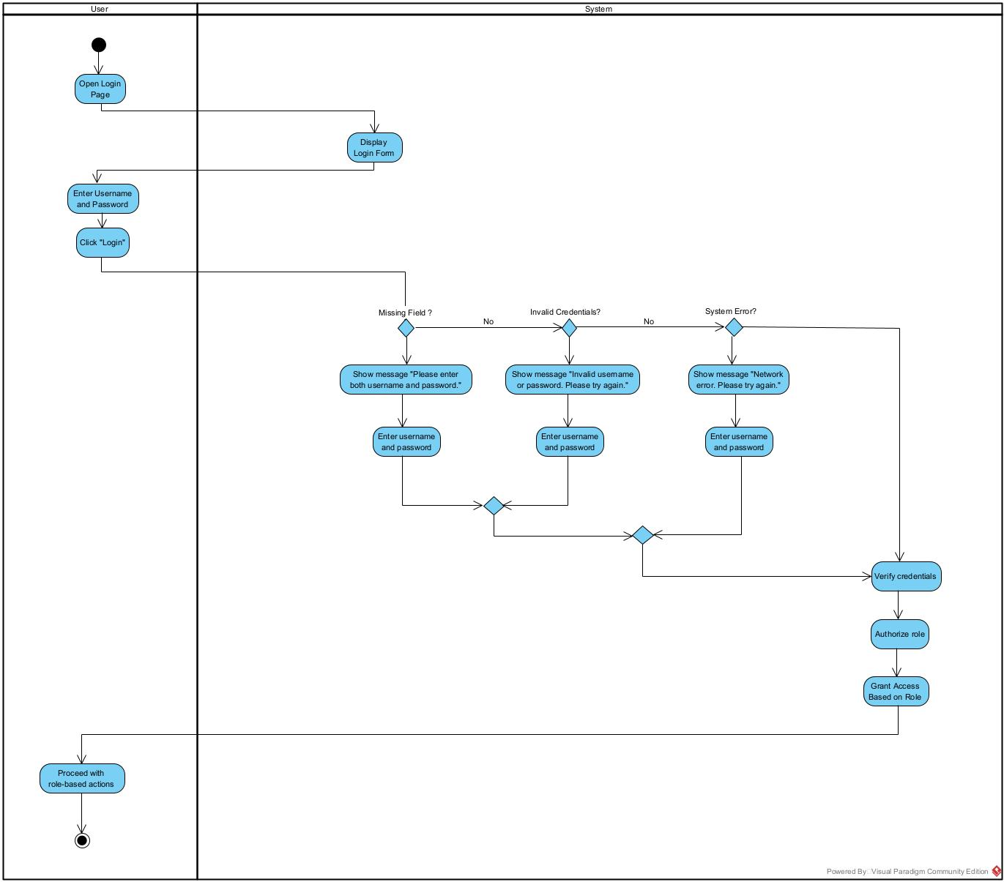

**Register Admissions Consulting**

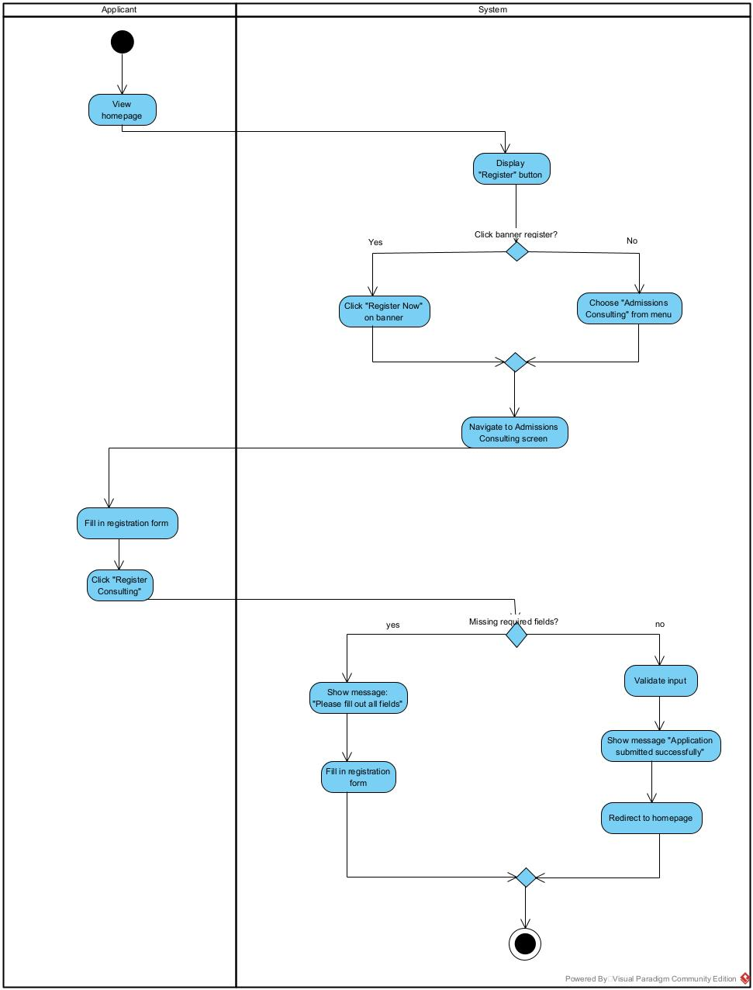

**View Application Status**

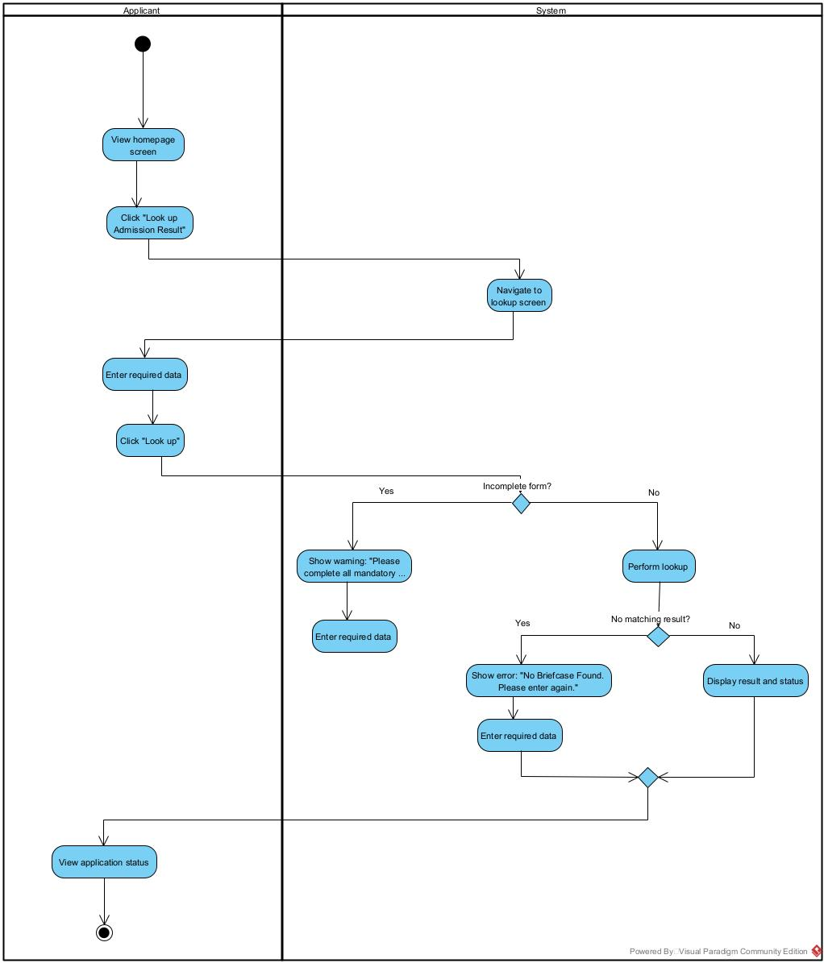

**Update Admissions Stage**

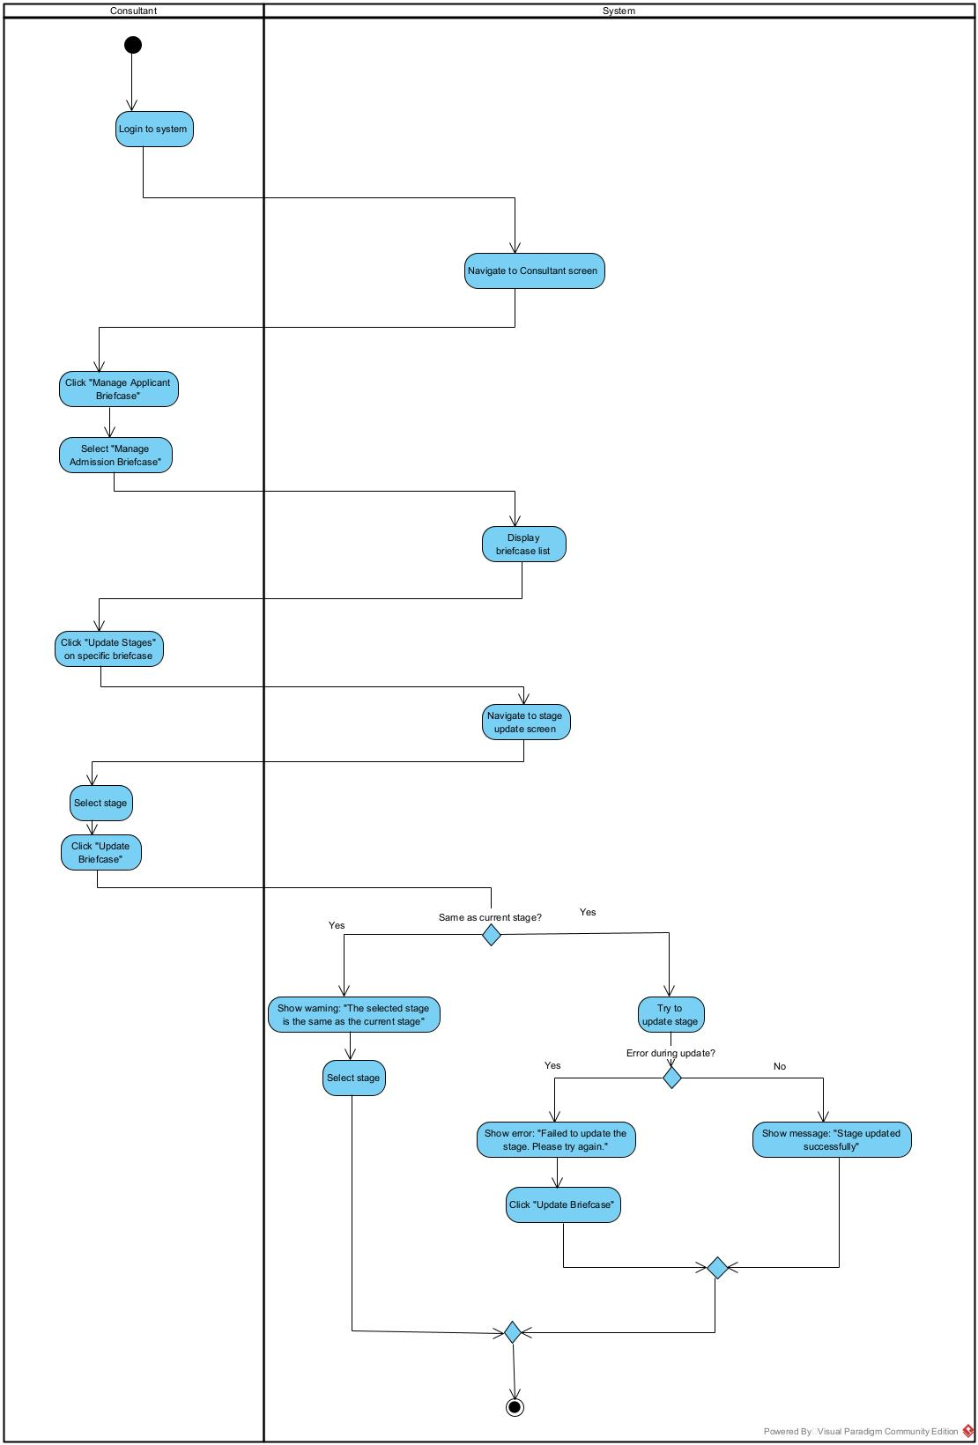

**Delete Admissions Briefcase**

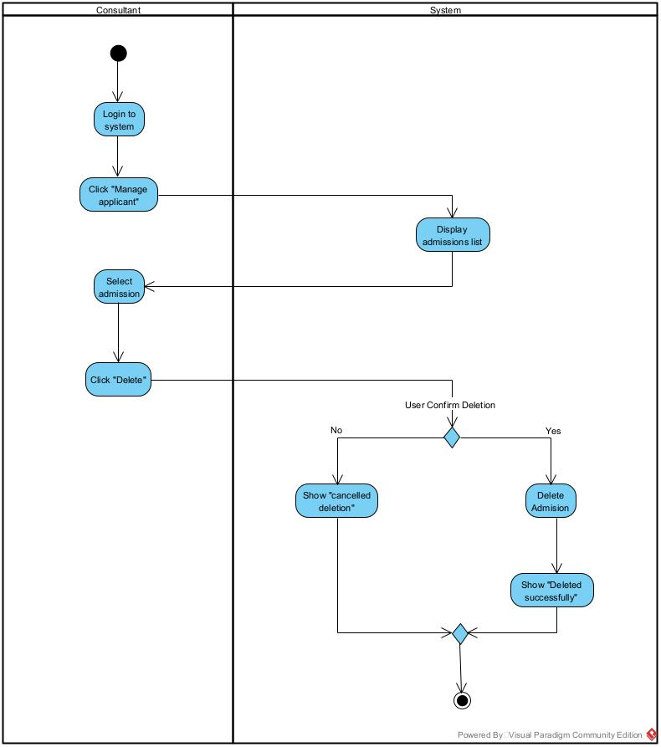

**View Admissions Briefcase**

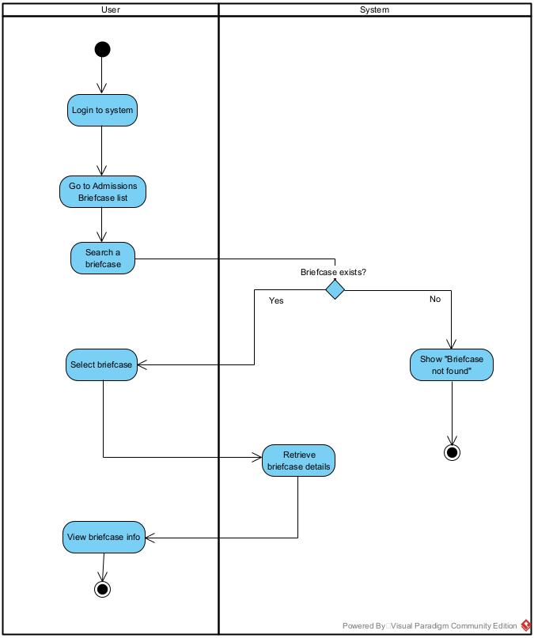

**Admin Create User Account**

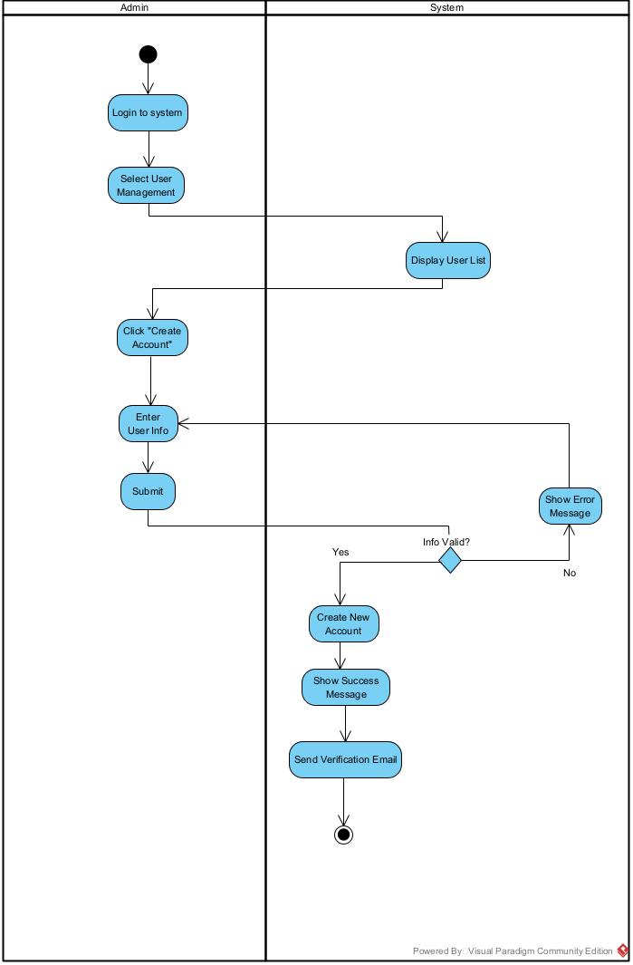

**Chatting with AI Chatbot**

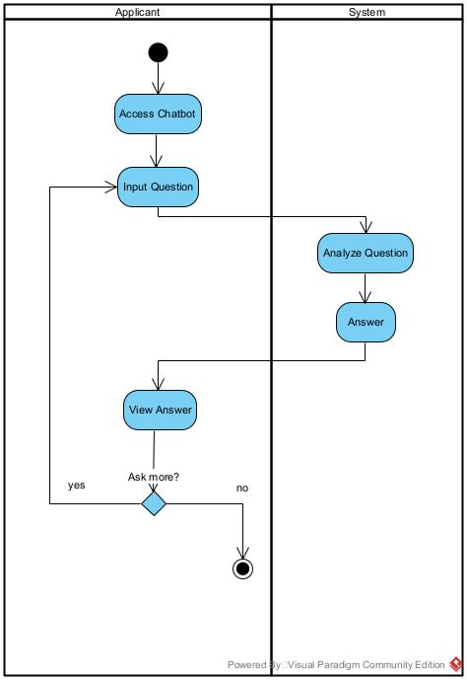

**Admin Dashboard Overview**

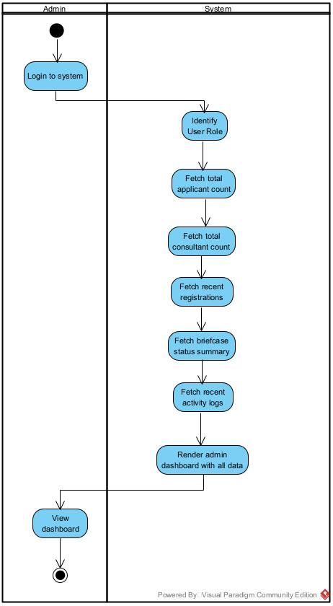

**Consultant Dashboard Overview**

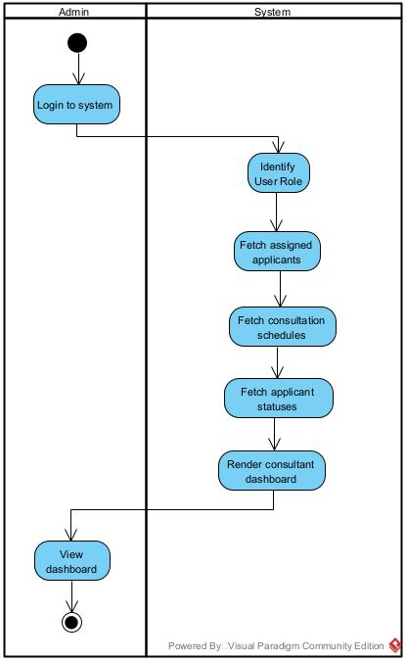

**Applicant Dashboard Overview**

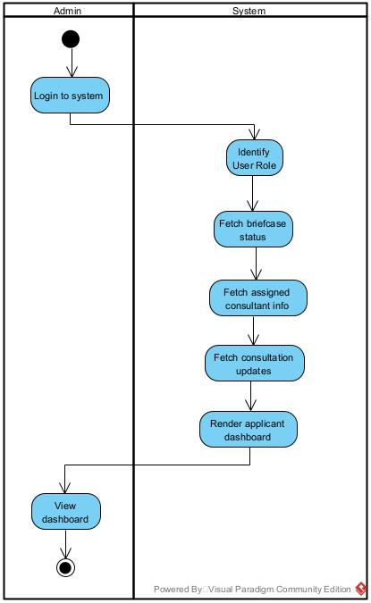

**Update User Account**

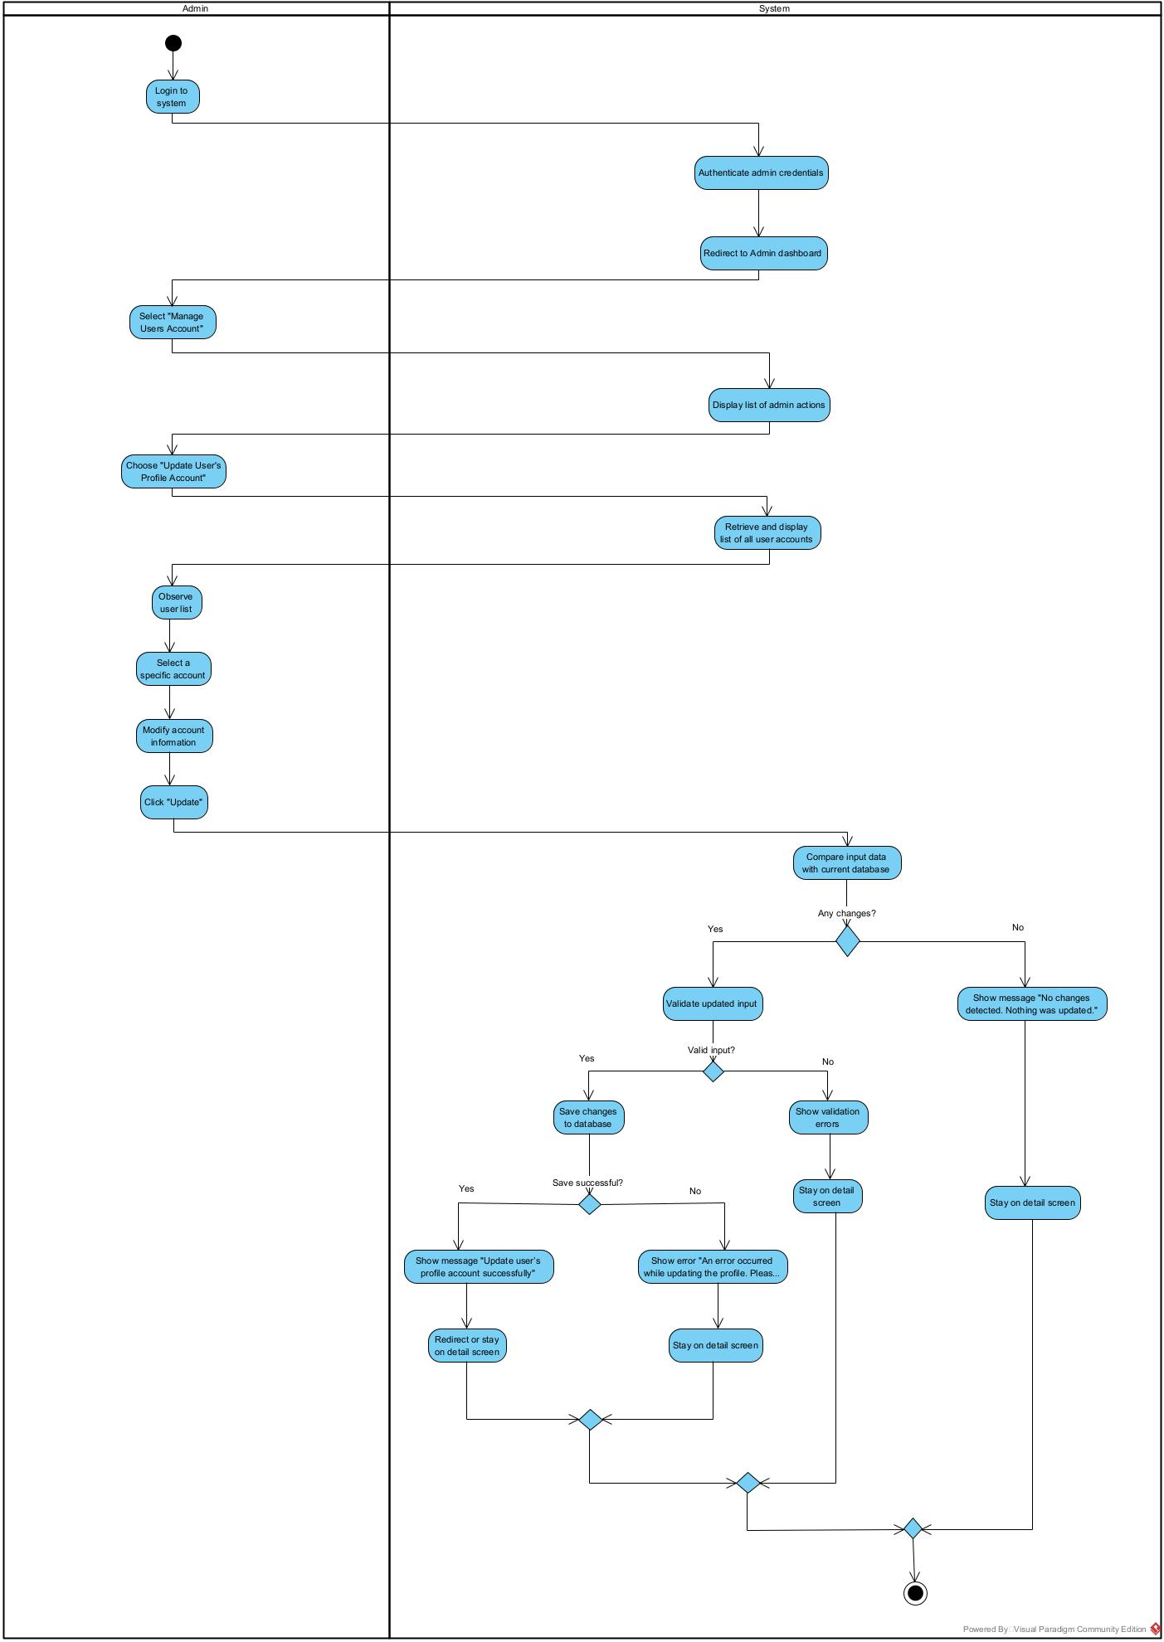

**Search Briefcase**

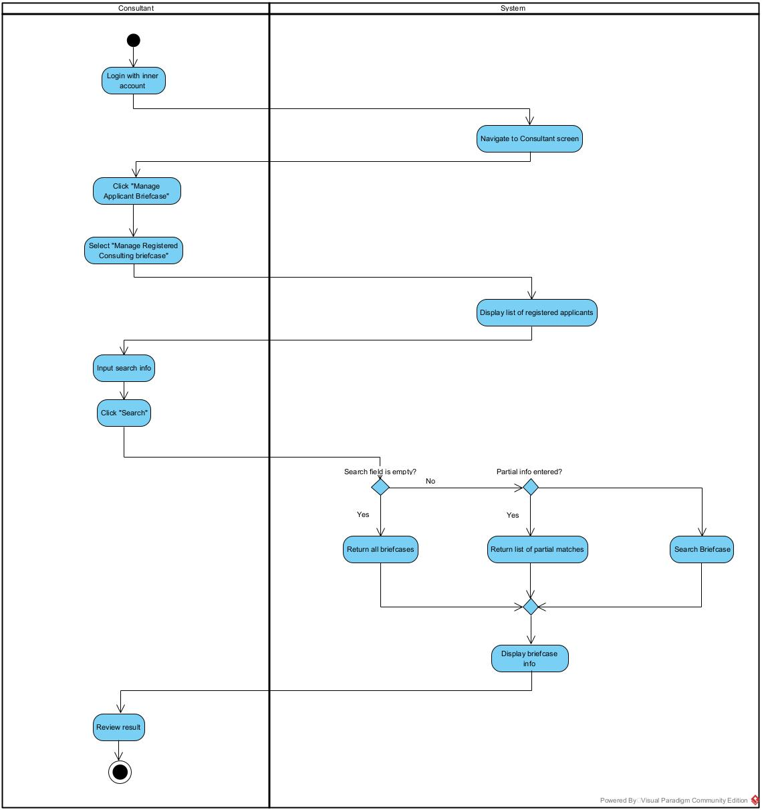

**View school rank**

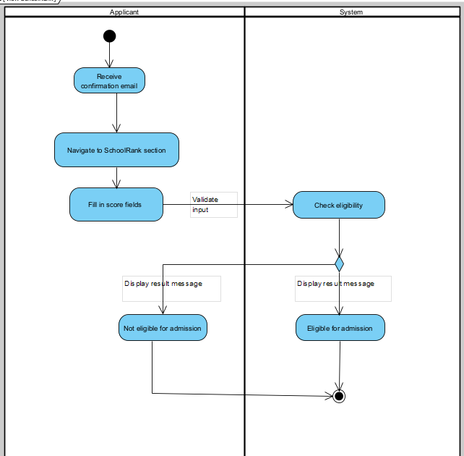

**Admissions Consulting Form**

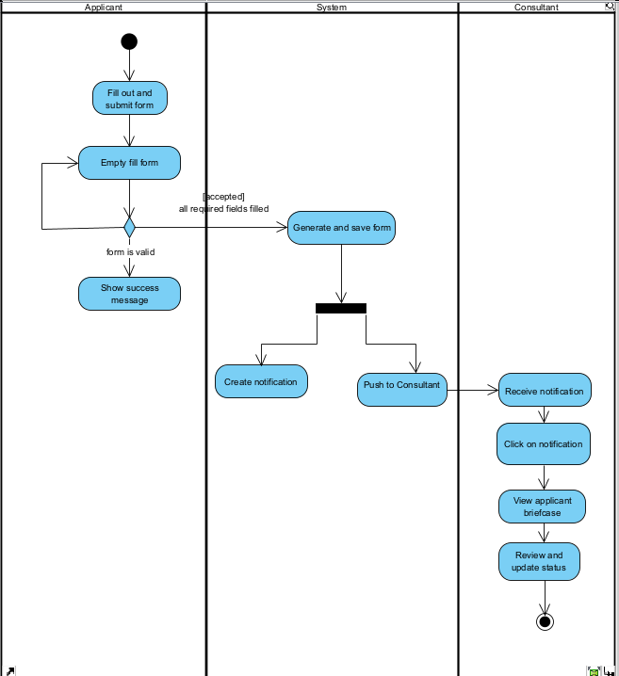

***II.6 Entity Relationship Diagram***

1. ***Conceptual diagram***

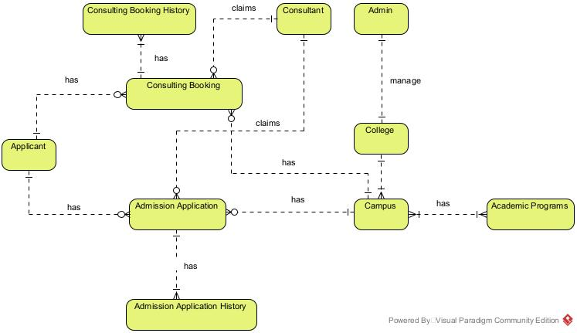

1. **Logical diagram**

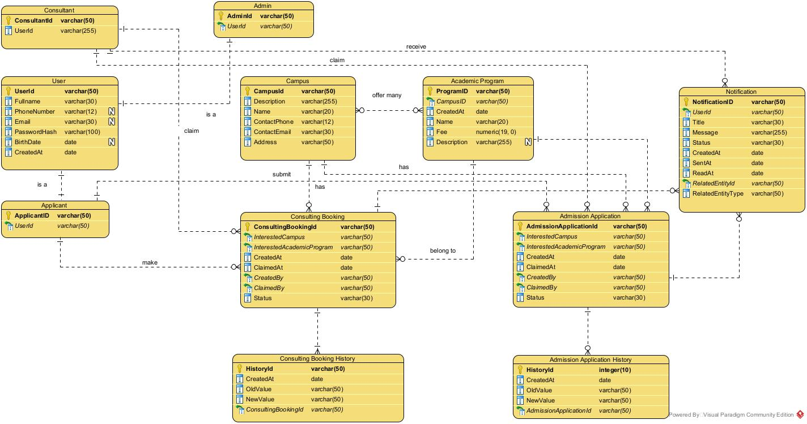

**3. Physical diagram**

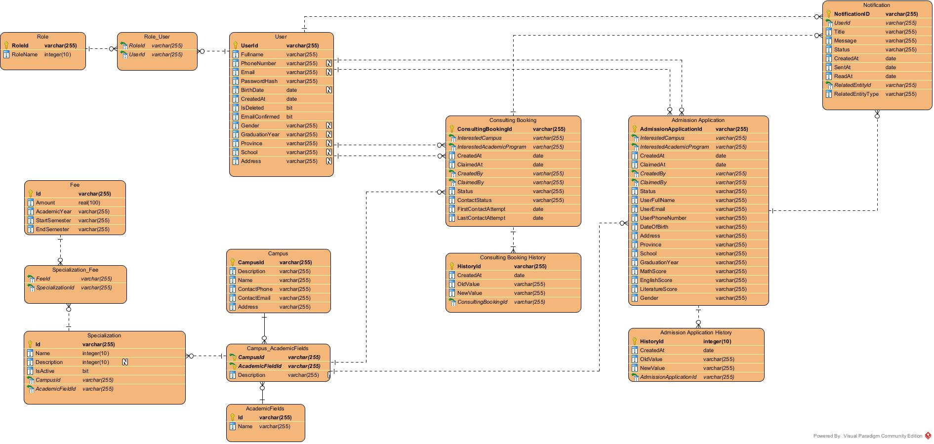

# III. Analysis models.

## III.1 Interaction diagrams

### III.1.1.Sequence Diagram

1. Login**(SE.1)**

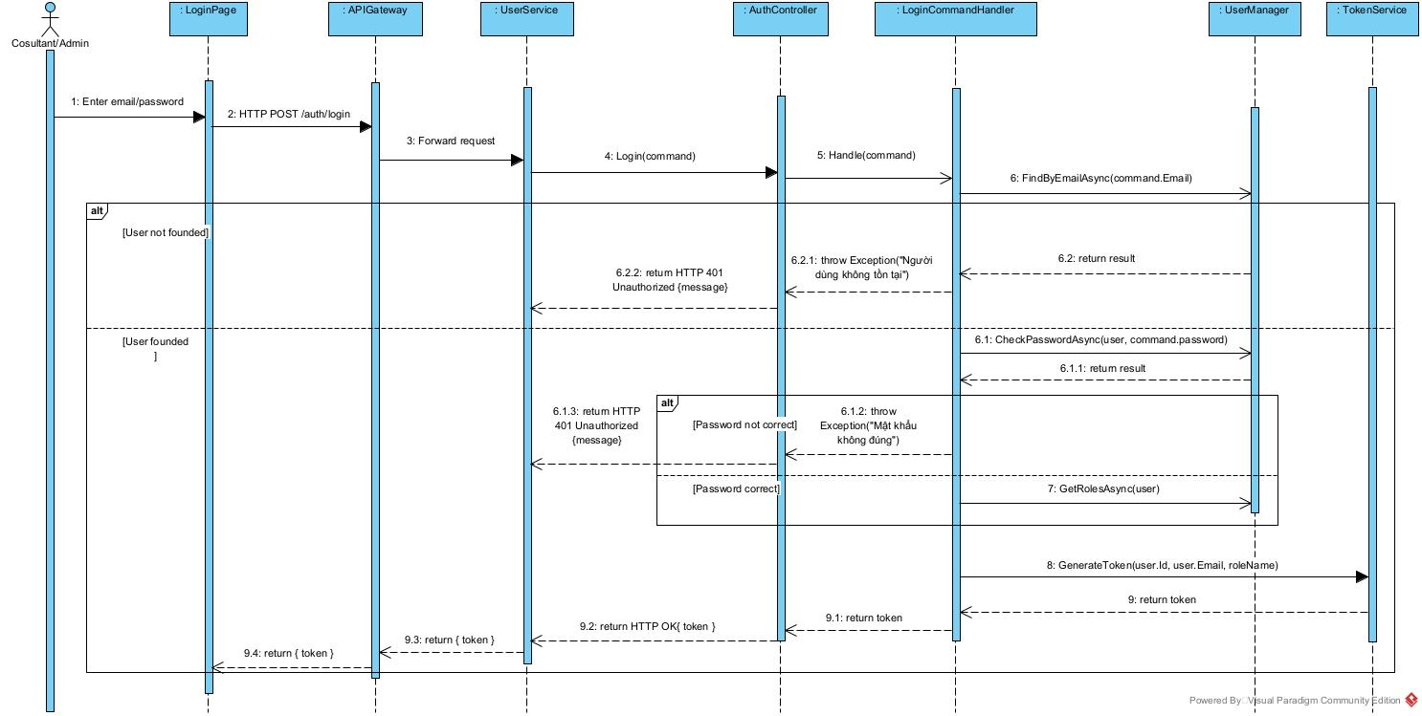

1. Create Consultant**(SE.2)**

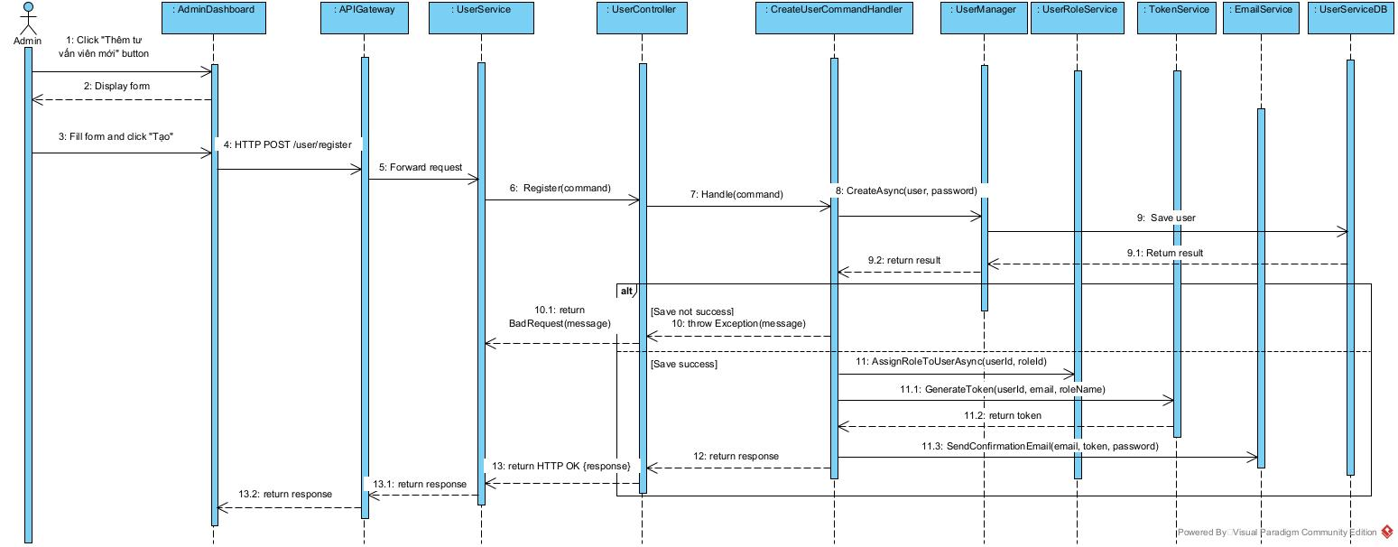

1. Create Consulting Booking**(SE.3)**

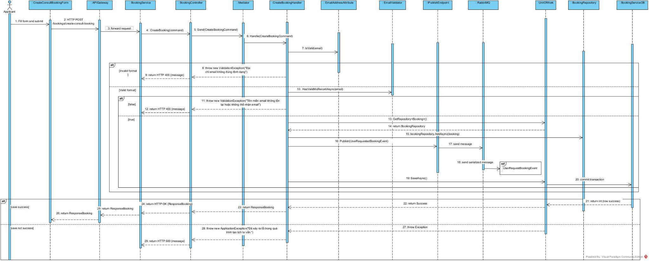

1. UserRequestBooking Event (**SE.4**)

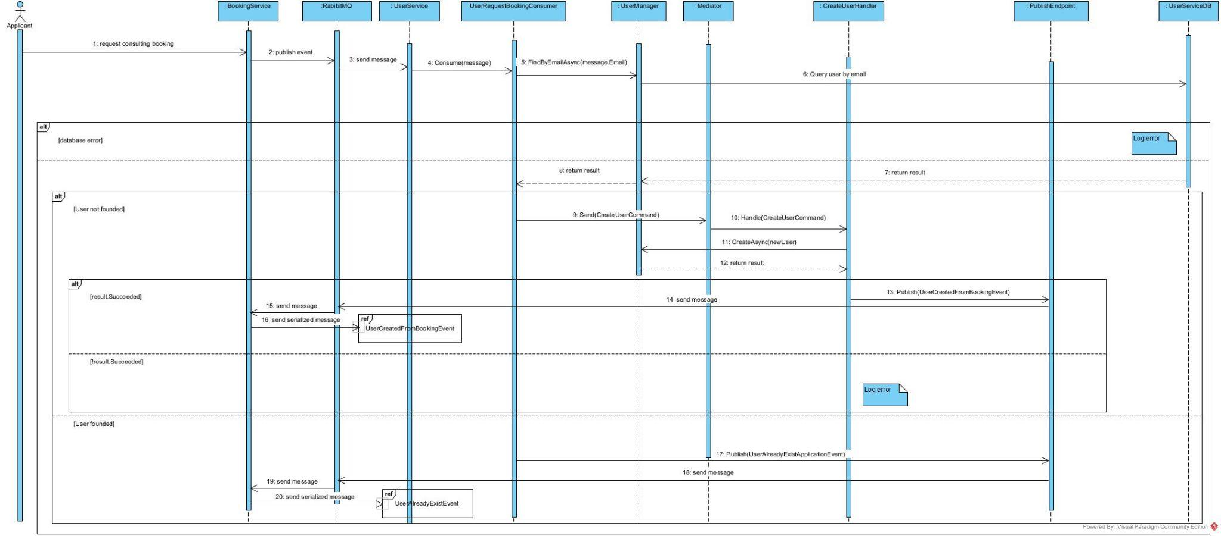

1. UserAlreadyExist Event (**SE.5**)

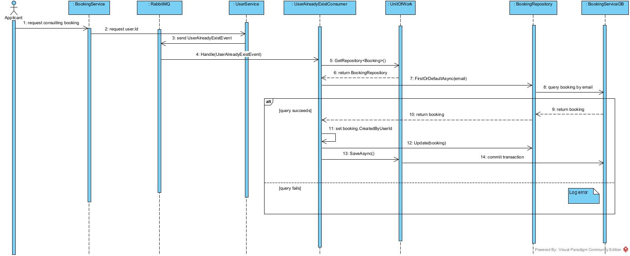

1. UserCreatedFromBooking Event **(SE.6)**

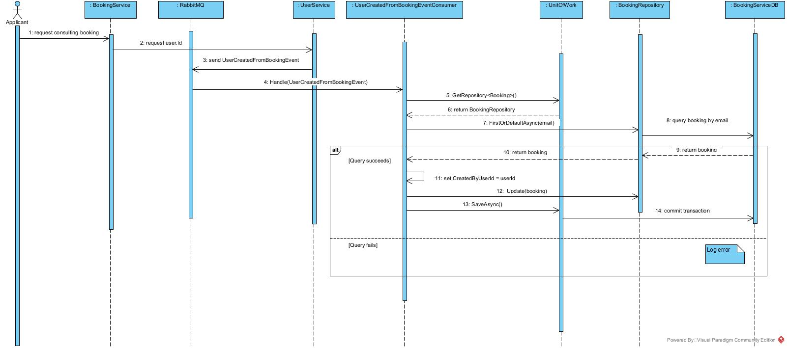

1. Claim Consulting Booking**(SE.7)**

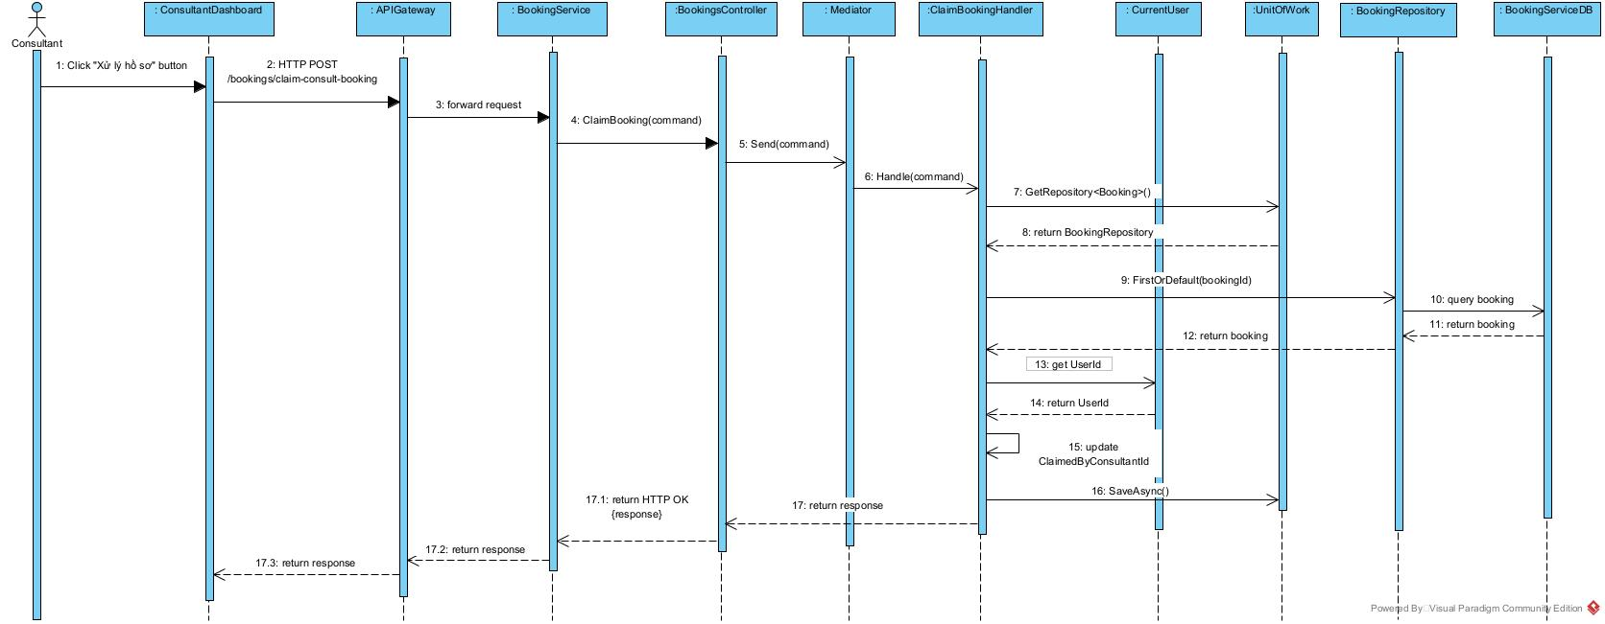

1. Update Consulting Booking Status**(SE.8)**

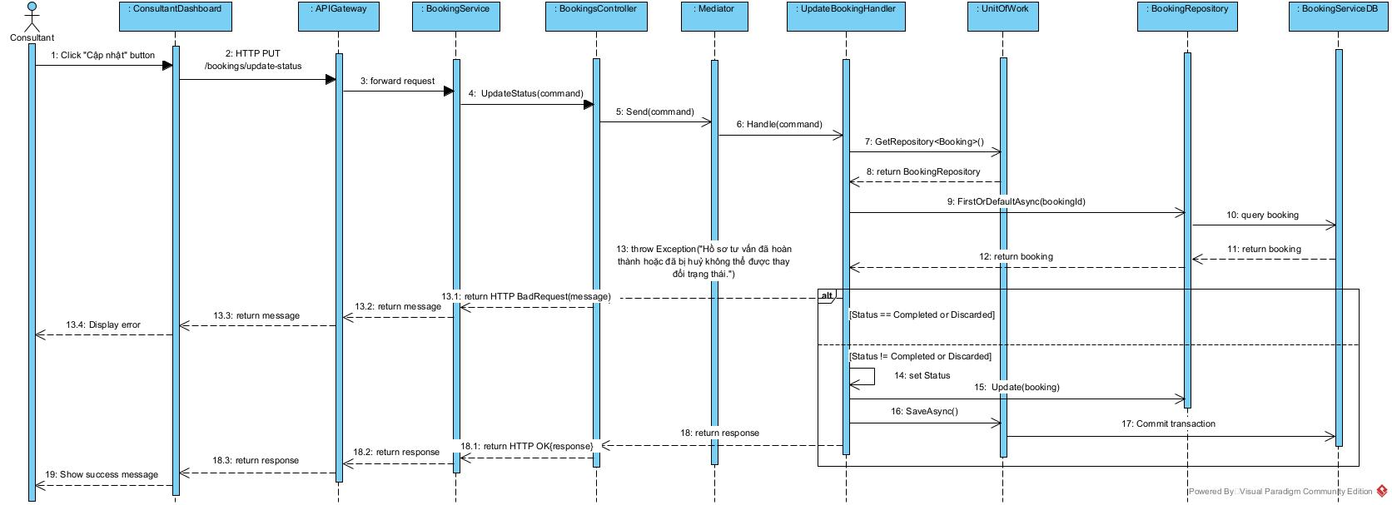

1. View Consulting Booking**(SE.9)**

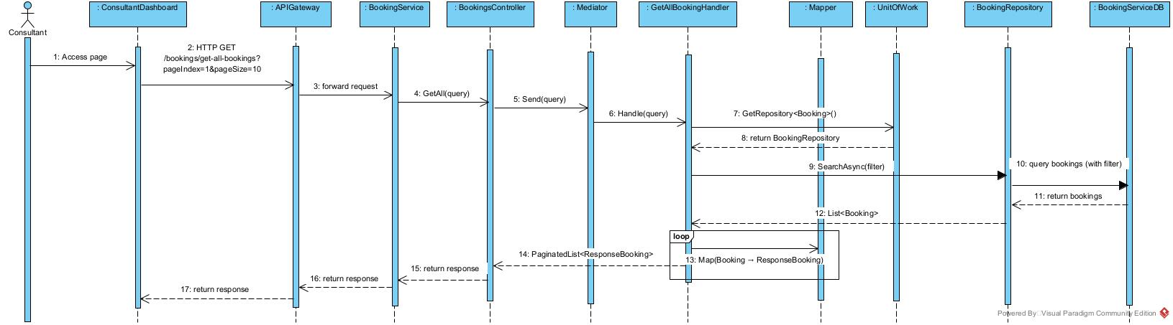

1. Create Application Booking**(SE.10)**

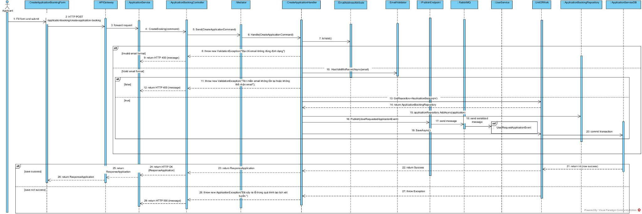

1. UserRequestApplicationBooking Event (**SE.11**)

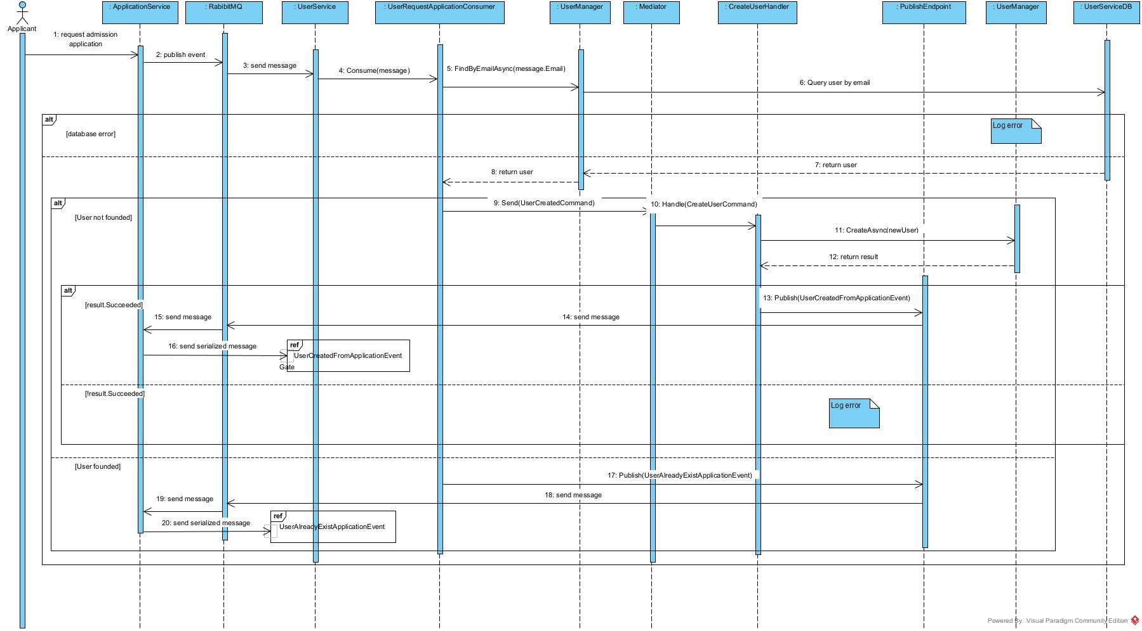

1. UserAlreadyExistApplication Event (**SE.12**)

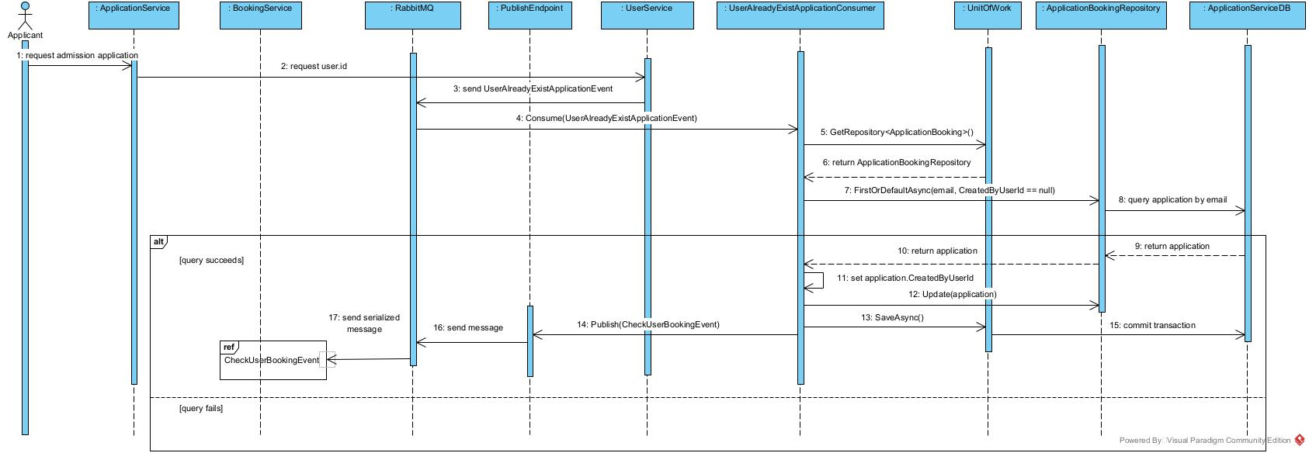

1. Check User has Claimed Booking Event **(SE.13)**

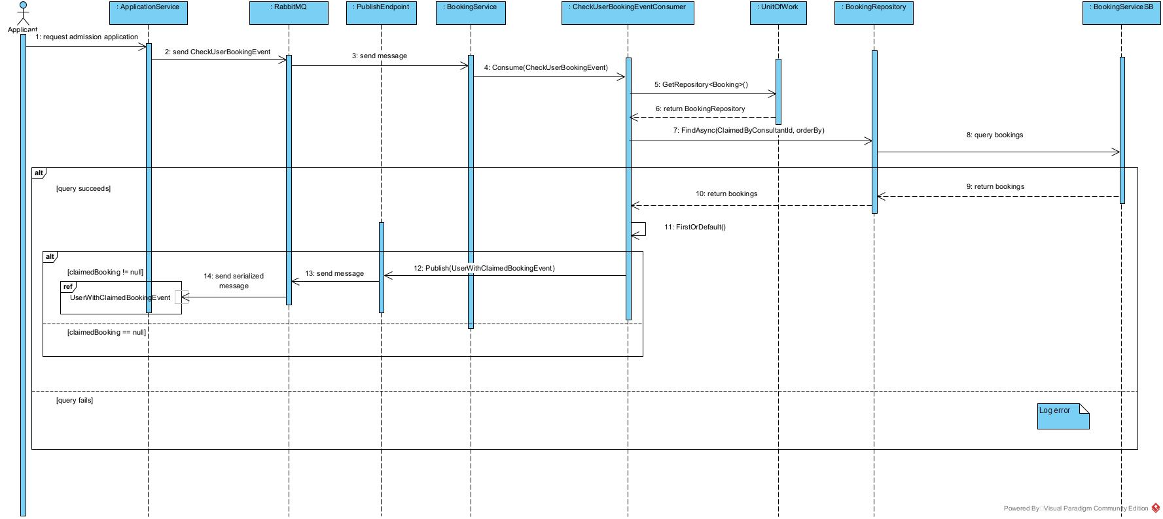

1. User with Claimed Booking Event **(SE.14)**

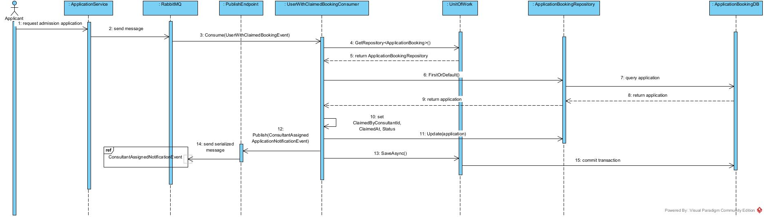

1. Consultant Receive Notification for assigned Application**(SE.15)**

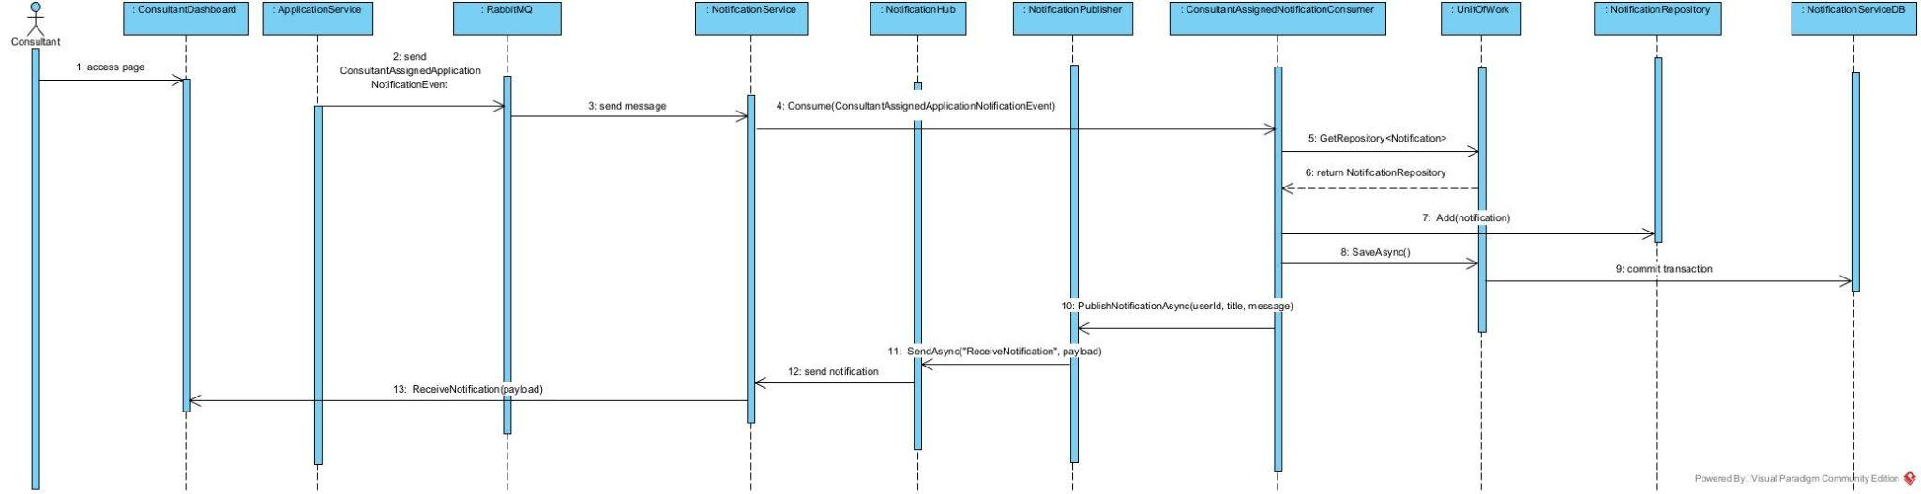

1. Consultant View Notifications for assigned Application(**SE.16**)

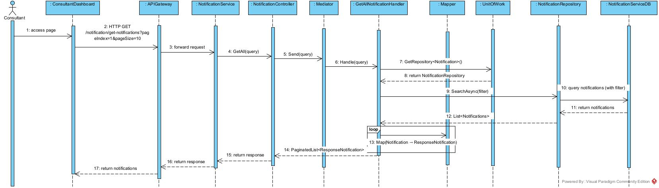

1. View Application Booking**(SE.17)**

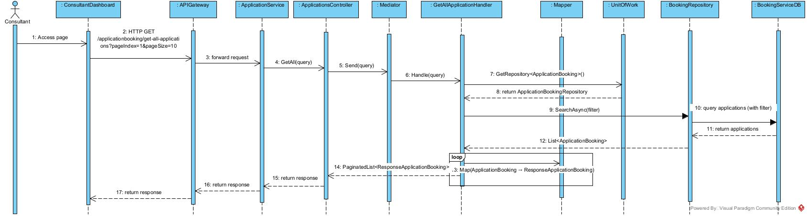

1. Claim Consulting Booking**(SE.18)**



1. Update Application Booking Status**(SE.19)**

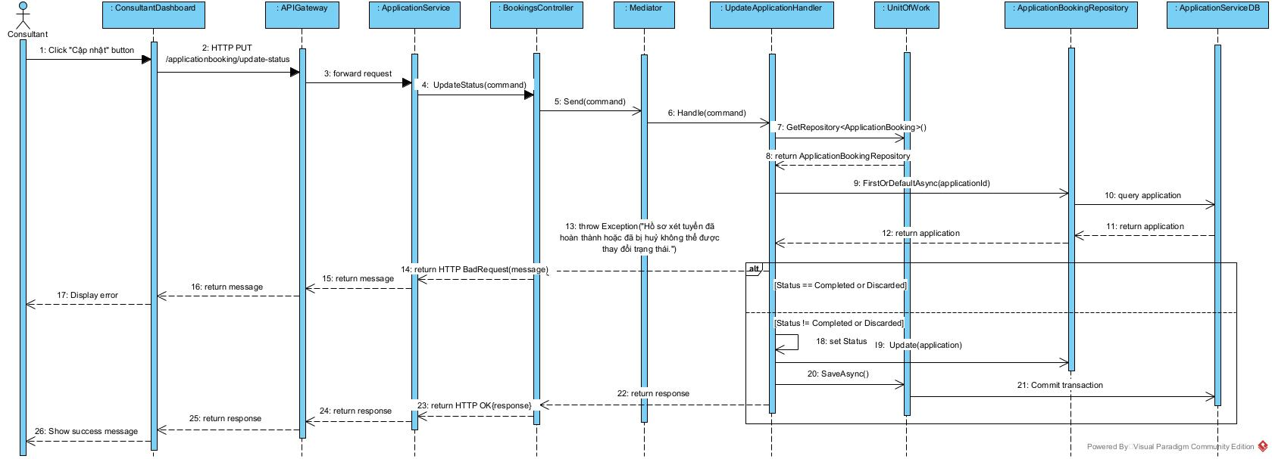

1. Update UserId after creating a Booking**(SE.20)**

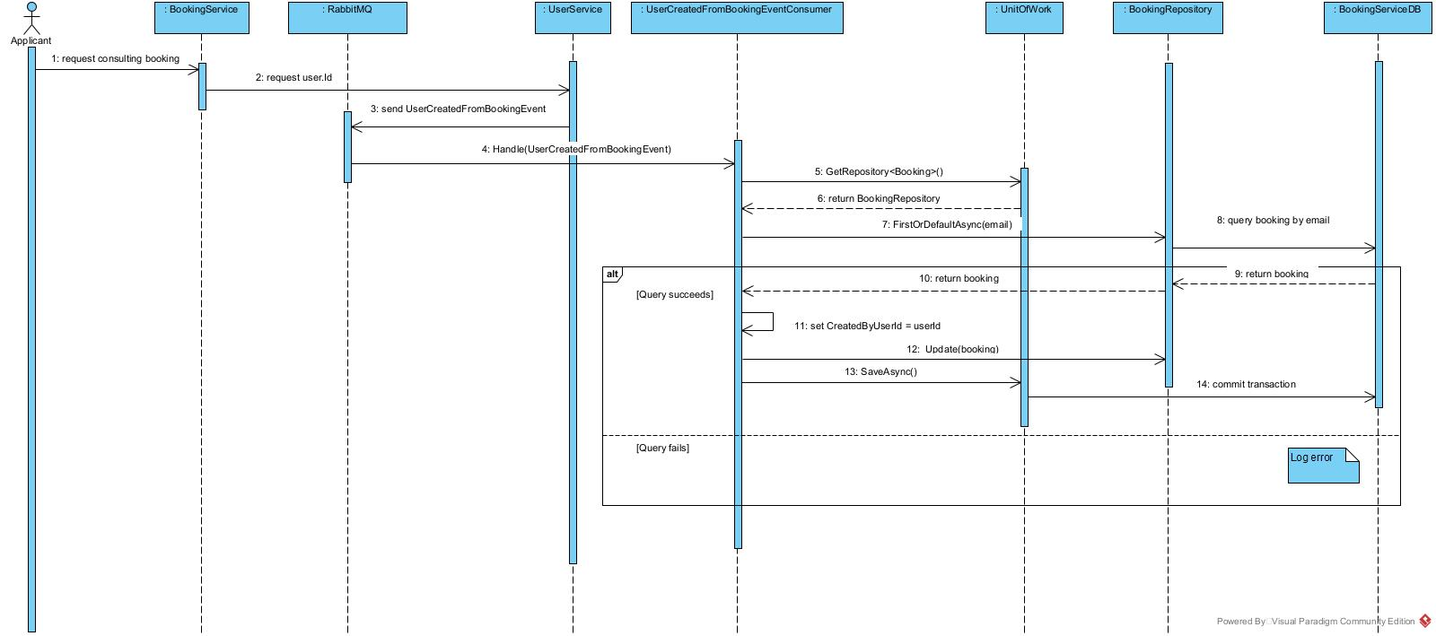

1. Update UserId after creating a Application**(SE.21)**

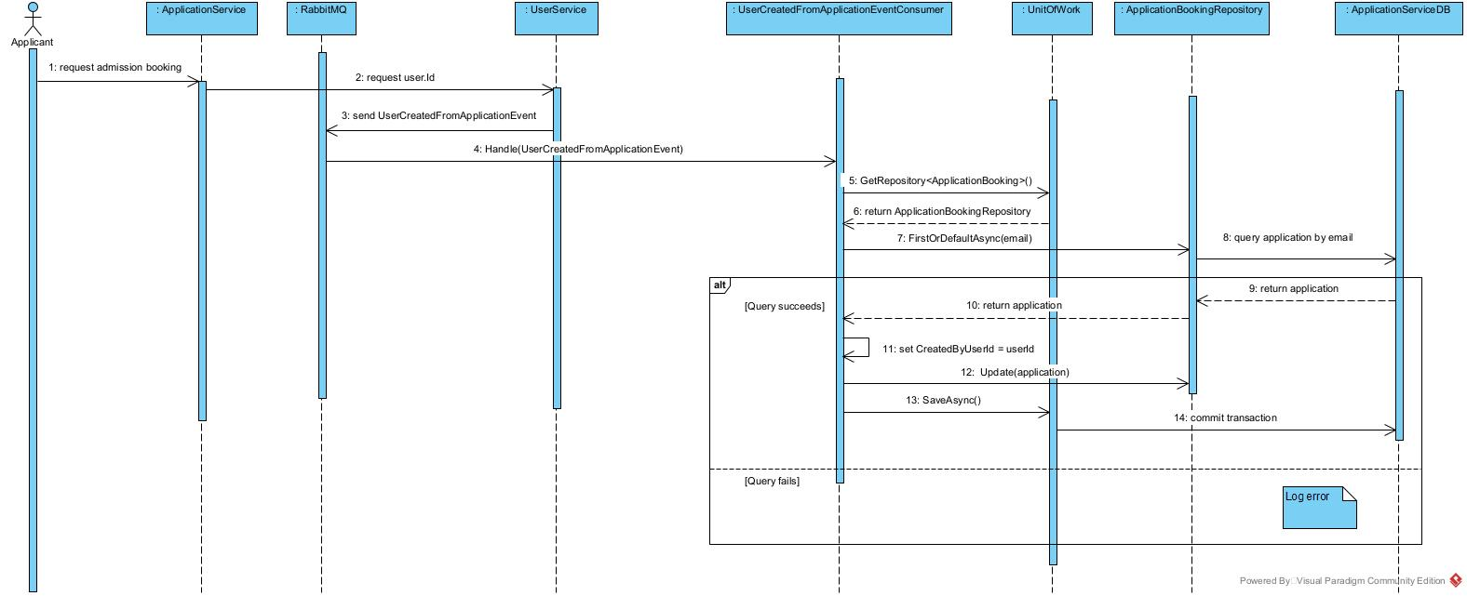

1. Student get Campus Info By Id**(SE.22)**

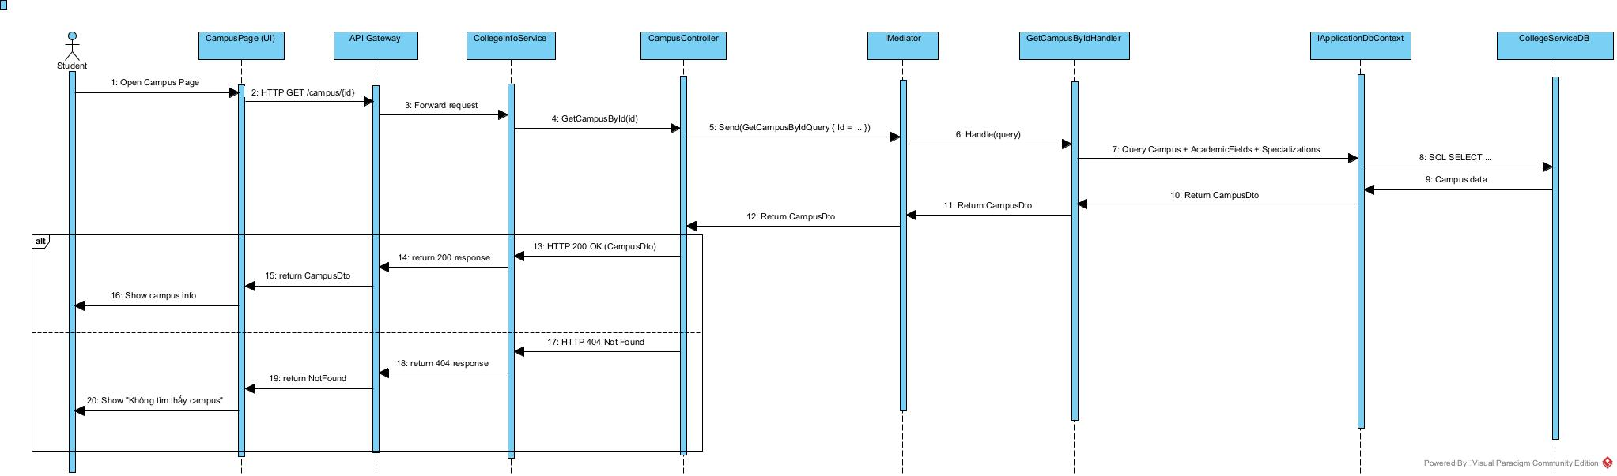

1. Student get Campus Info By Name**(SE.23)**

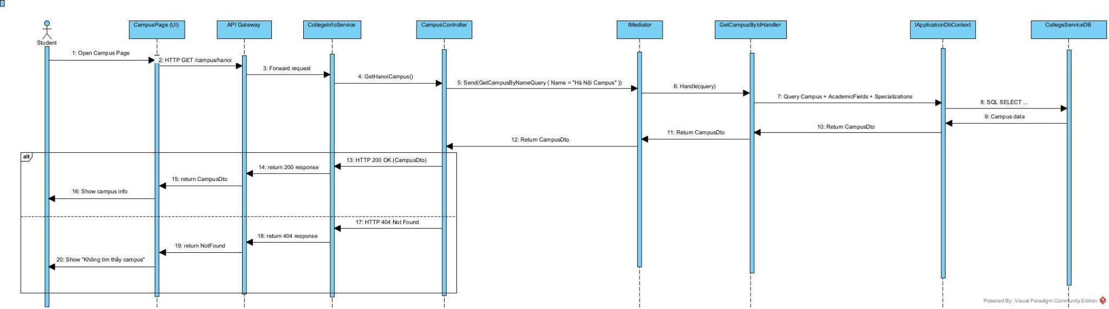

1. Student get Campus List**(SE.24)**

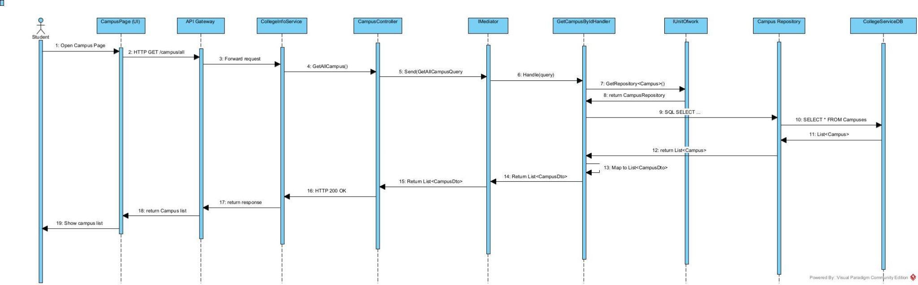

### III.1.2.Communication Diagram

## III.2 State diagram

Applicant booking

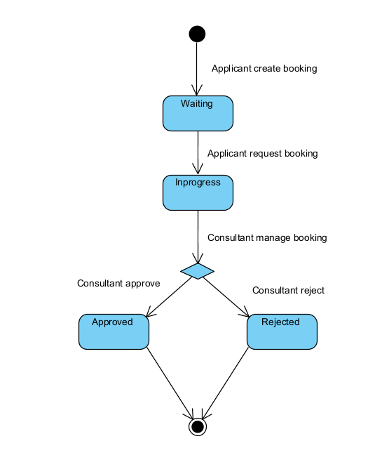

Applicant apply application

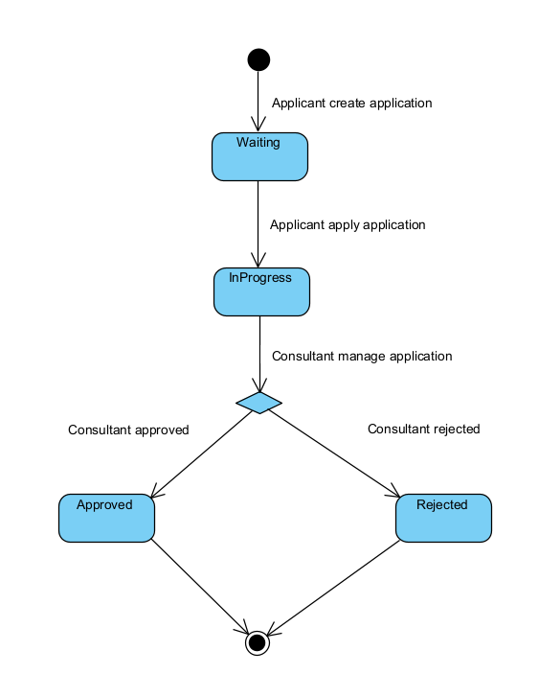

Applicant booking Consultant

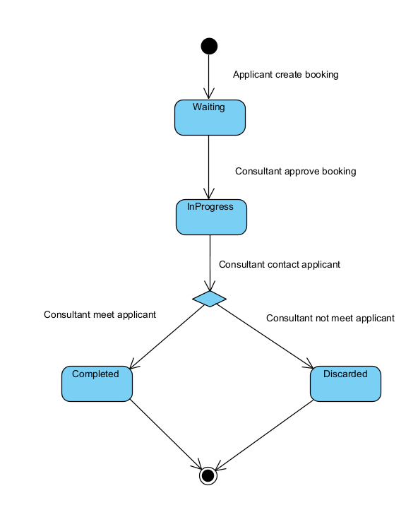

# IV. Design specification

## IV.1 Integrated Communication Diagrams

## IV.2 System High-Level Design

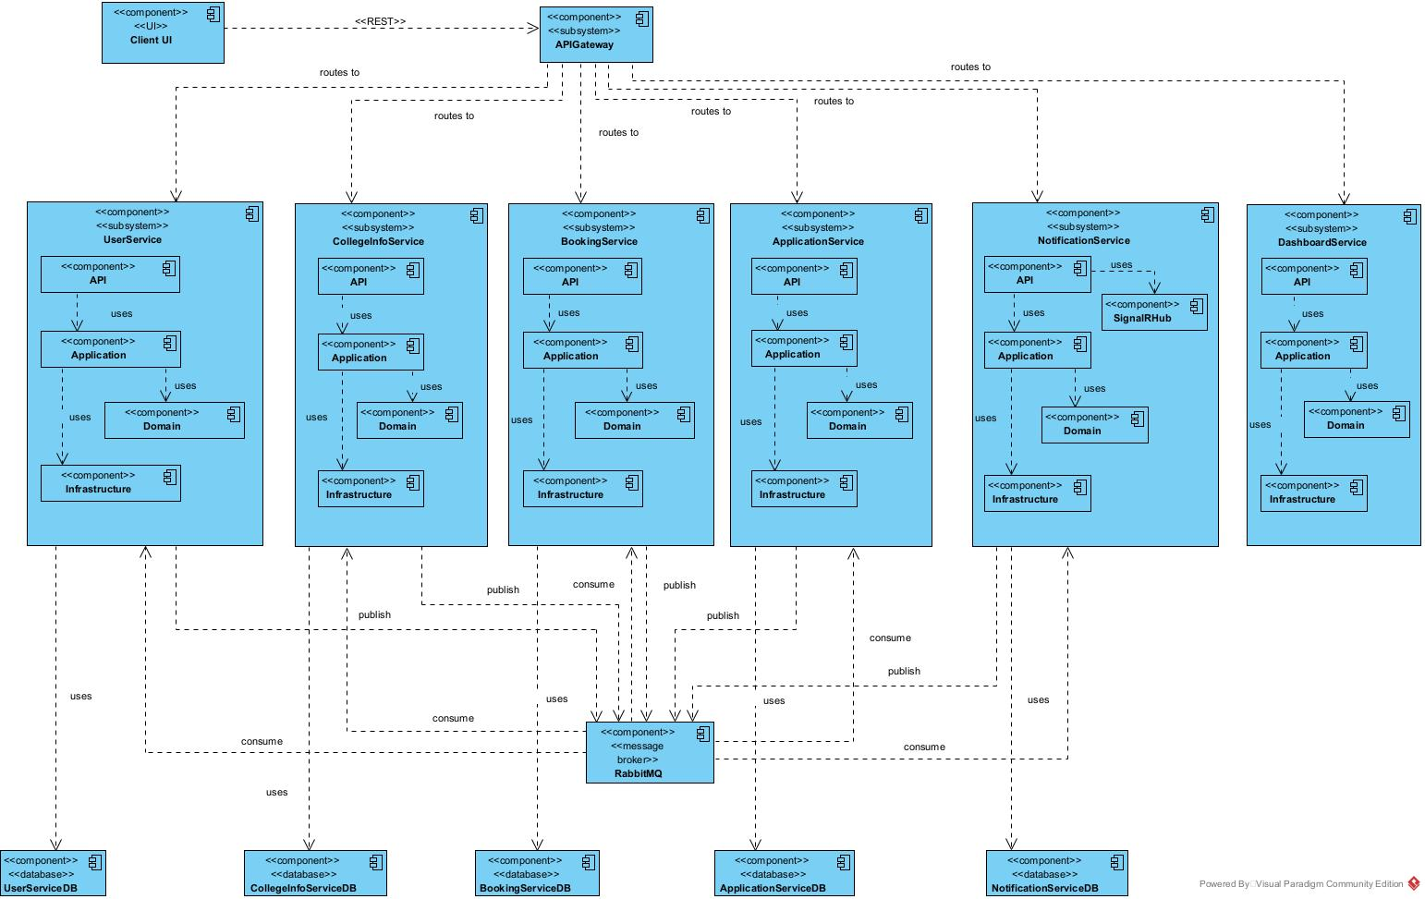

## IV.3 Component and Package Diagram

## IV.3.1 Component Diagram

## IV.3.2 . Package Diagram

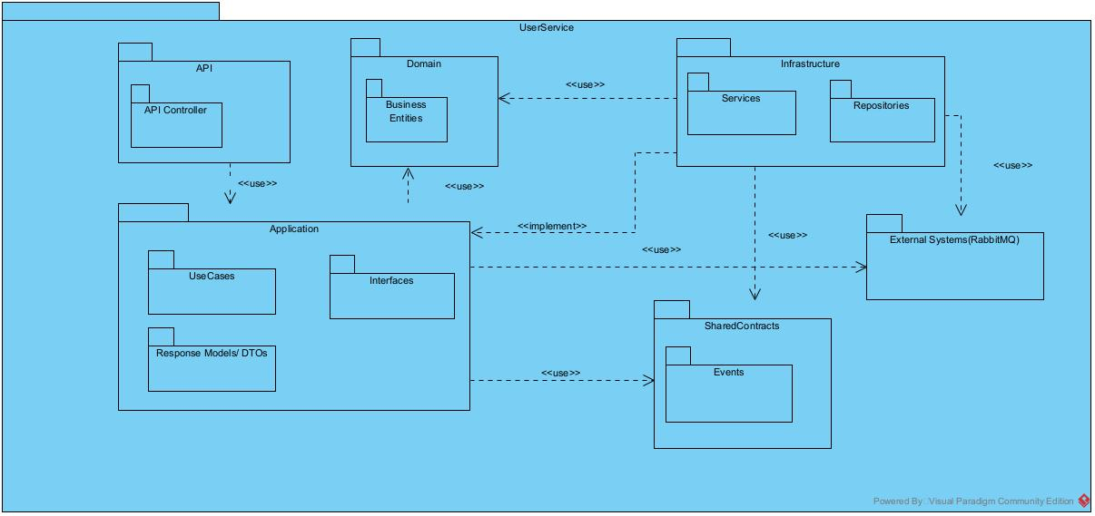

*This diagram of the UserService demonstrates a standardized architectural template (or blueprint / pattern) that can be applied to other services (BookingService, ApplicationService, CollegeInfoService, NotificationService) within the system*

| ***No*** | ***Package*** | ***Description*** |
| --- | --- | --- |
| 01 | UserService | Represents the entire User Service as a cohesive application. |
| 02 | API | Outermost layer responsible for handling external requests and exposing the service's functionality. |
| 03 | API Controller | Package contains the controller classes that define the HTTP endpoints of the service. |
| 04 | UseCases | Define the specific application-level operations and workflows (e.g., "CreateUser", "GetAllUser"). |
| 05 | Interfaces | Define abstract contracts (ports) that the Infrastructure layer must implement. |
| 06 | Response Models/ DTOs | Data Transfer Objects used to shape the data returned to the API layer or exchanged within the application. |
| 07 | Domain | Containing the enterprise-wide business rules, entities, value objects, and domain services |
| 08 | Business Entities | Represent the core business concepts and their behaviors |
| 09 | Infrastructure | This layer handles external concerns and technical implementations required by the Application layer. |
| 10 | Services | Refer to concrete implementations of external integrations or specific technical services (e.g., email notification service) |
| 11 | Repositories | Handle data persistence mechanisms, abstracting away the details of the database or other data stores |
| 12 | SharedContracts | This package holds data contracts or definitions that are intended to be shared across multiple services or components within the system. |
| 13 | Events | Defines the structure of domain events or integration events (e.g., UserCreatedEvent) that can be published or consumed by various parts of the system or other services. |

## IV.4 Class diagram

1. User create consulting booking class diagram **(CD.1)**

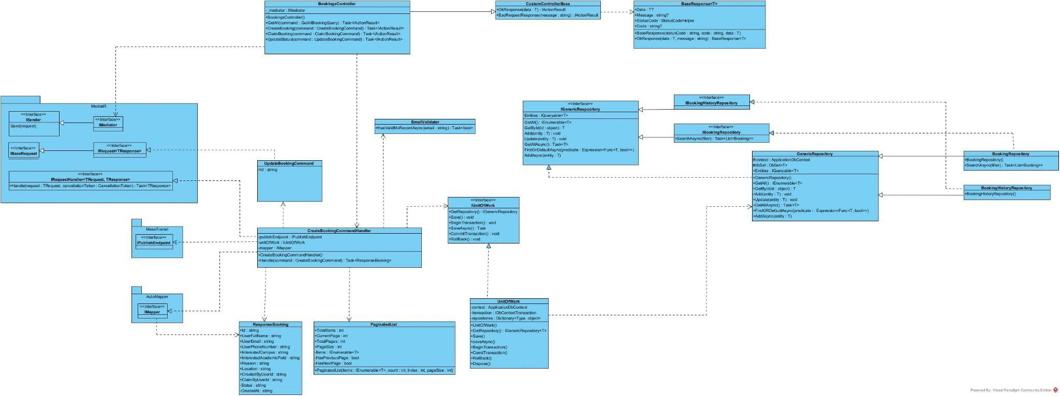

1. Consultant claim consulting booking class diagram **(CD.2)**

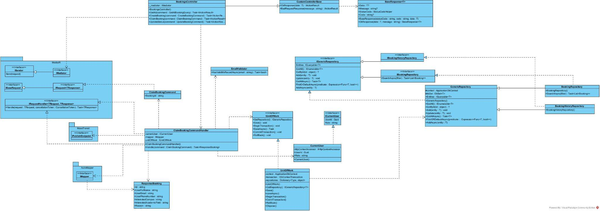

1. Update consulting booking class diagram **(CD.3)**

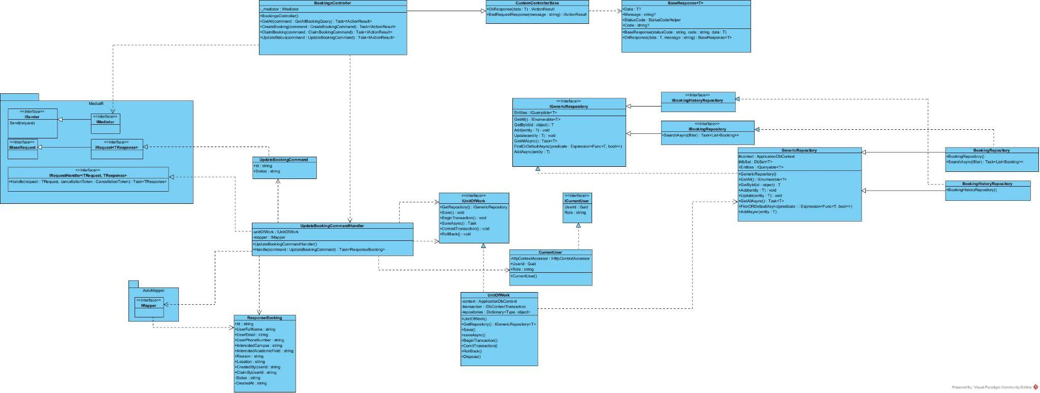

1. Get all consulting booking class diagram **(CD.4)**

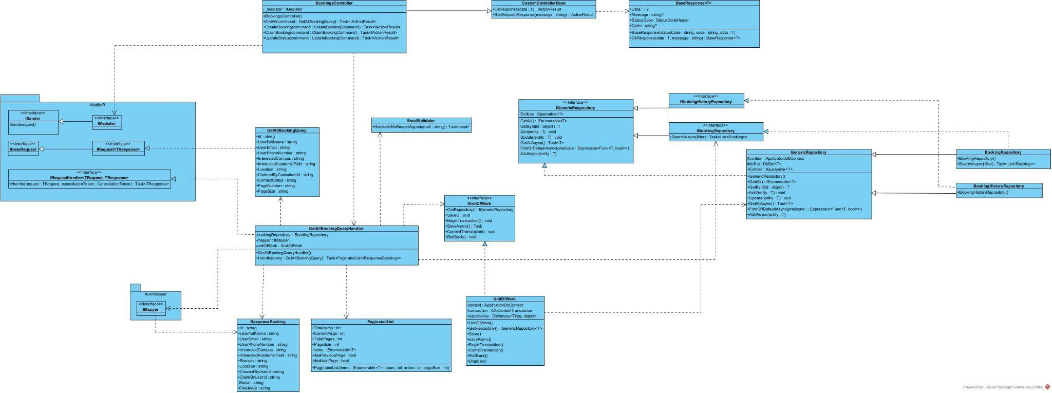

1. User service class diagram **(CD.5)**

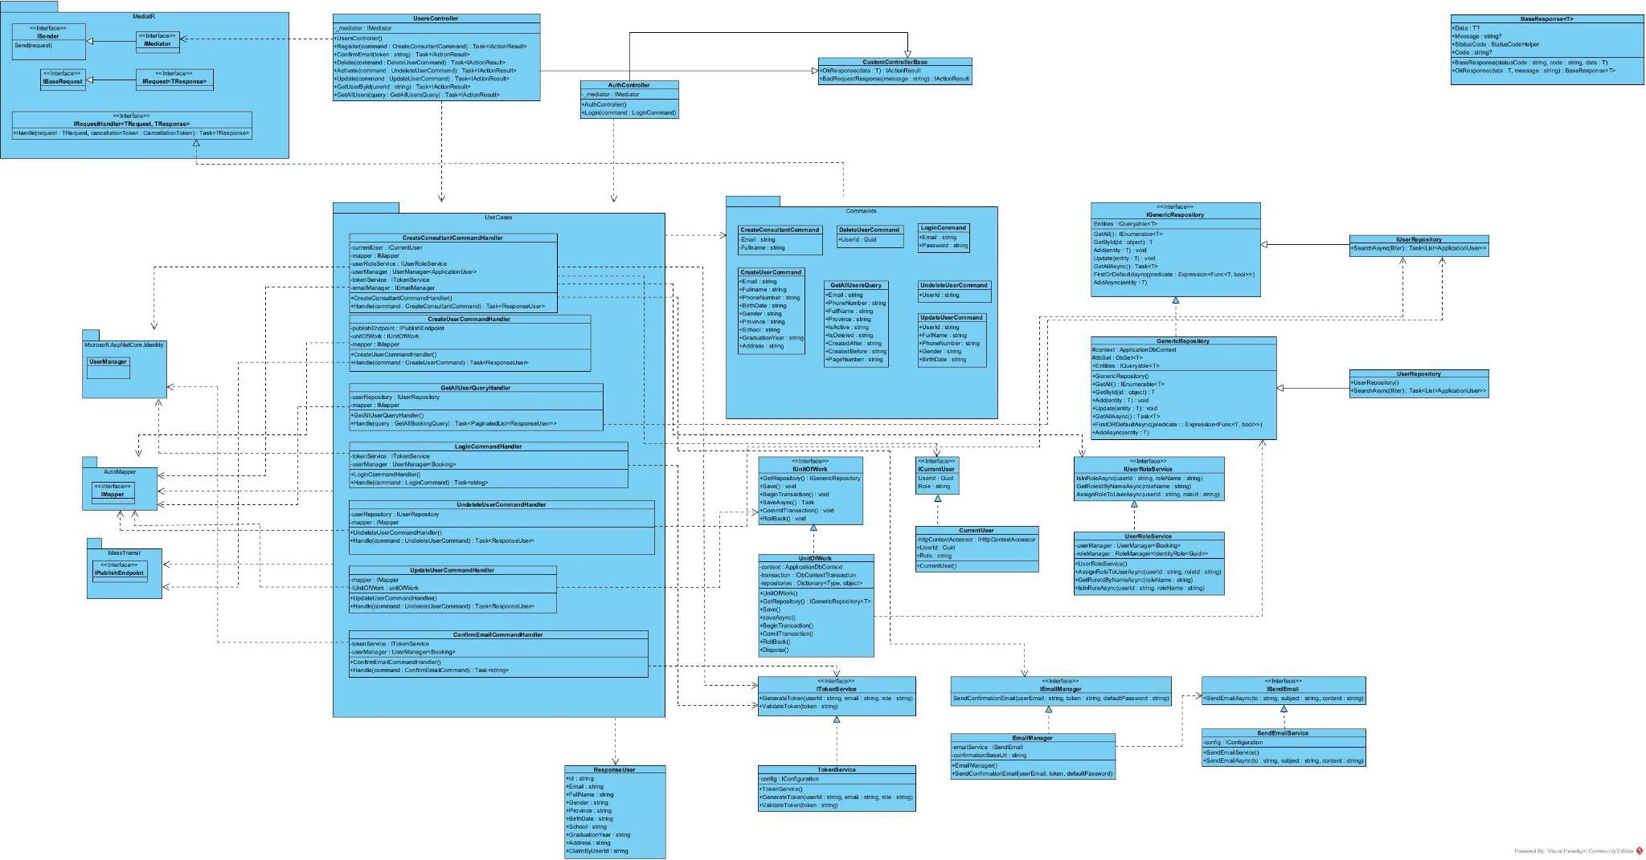

## IV.5 Database Design

*https://drive.google.com/drive/folders/1x5N15KhKlPVIv4_uKgQIzcVrJV1GPS9m*

UserServiceDB

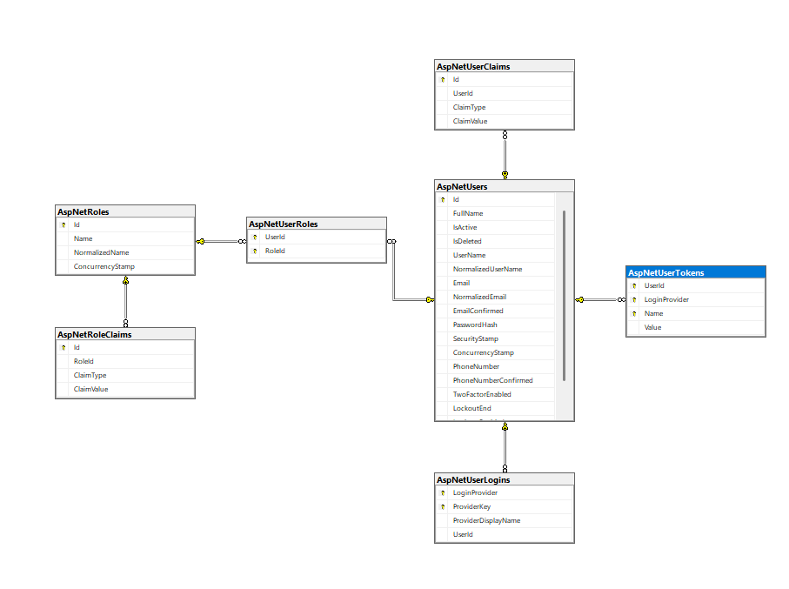

ApplicationServiceDB

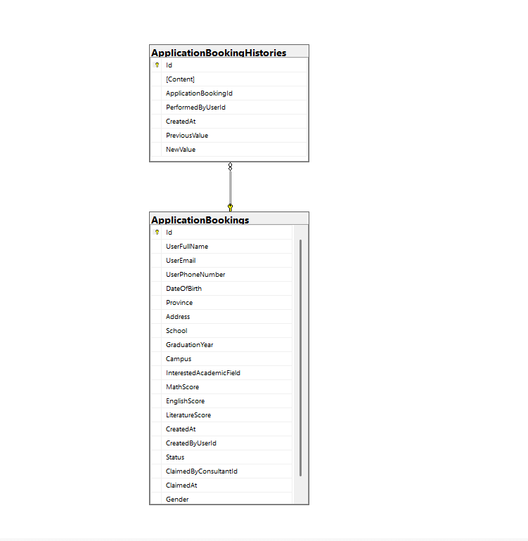

BookingServiceDB

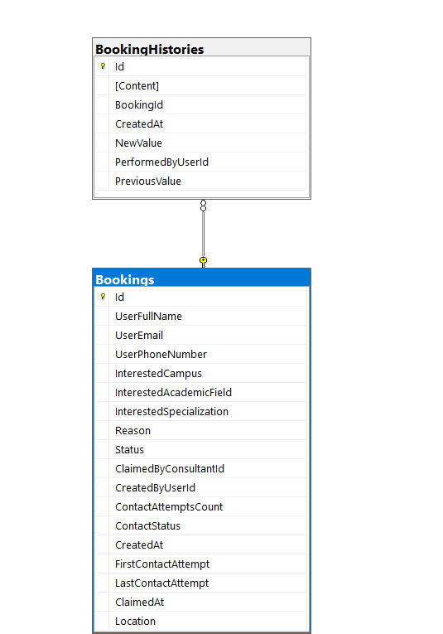

NotificationServiceDB

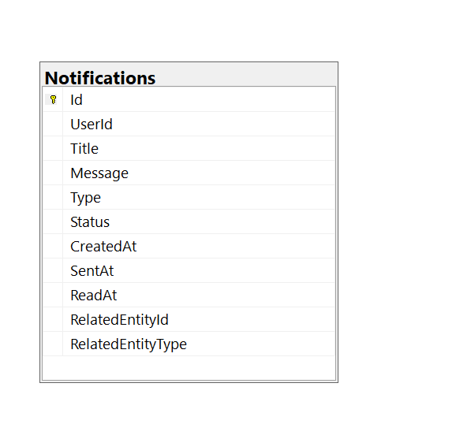

CollegeInfoServiceDB

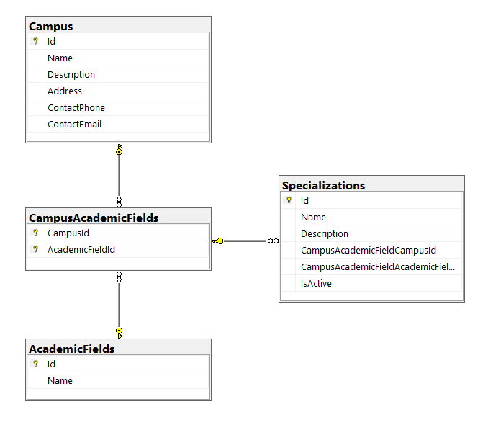

# V. Implementation

## V.1 Map architecture to the structure of the project

## V.2 Map Class Diagram and Interaction Diagram to Code

# VI. Applying Alternative Architecture Patterns

## VI.1 Applying the ………….. (ex: Service-Oriented Architecture (SOA)) architecture

## VI.2 Applying Service Discovery Pattern in the service-oriented architecture